Machine Learning & Data Science
Consolidated & Corrected Notes
Organized in learning order • Errors corrected • Missing concepts added • Tricky interview Q&A included
Compiled from workbook sheets: ML, theory_01, theory_02, theory_03, classi, Git, Losses, Grad-D

How to Read This Document
Your original notes from all Excel sheets have been merged, reordered into a logical learning sequence, simplified, and expanded. The latest additions on loss functions and gradient-descent optimizers (SGD, Momentum, Nesterov, Adagrad, RMSProp, Adam) have been folded into Part 7 in the correct order. All images from the workbooks are kept and placed inside their correct topics; broken/black images have been repaired. Three kinds of highlighted boxes are used:
✔ Correction (yellow) — something in the original notes was wrong or misleading and has been fixed. Read these carefully; they are common interview traps.
＋ Added concept (green) — an important concept that was missing from the notes for that topic.
Q: Tricky Interview Questions — at the end of each part: only questions where people genuinely get confused. Simple questions were deliberately left out.

Summary of corrections made to the original notes
Topic | What was corrected
Bias & Variance | "Bias = training error, Variance = testing error" replaced with the correct definitions (model simplicity vs sensitivity to training data).
Entropy / Gini ranges | "Entropy is between 0 and 1" and "Gini 0 to 0.5" hold only for BINARY classification; general maxima are log2(k) and 1 − 1/k.
R-squared range | R² in [0,1] holds on training data with an intercept; on test data R² can be negative.
Weighted Cross-Entropy | Direction of the alpha parameter was reversed; alpha > 1 on the positive term penalizes false negatives more.
range(5) as Iterator | range is an iterable, not an iterator; isinstance(range(5), Iterator) is False.
git restore | restore does not move staging → repository (that is commit); it discards working changes / unstages with --staged.
git remote -V | Flag is lowercase: git remote -v.
Isolation Forest contamination | Flags the top-X% most anomalous points (highest scores / shortest paths), not the "bottom X%".
CNN under-sampling | Clarified CNN = Condensed Nearest Neighbour, not Convolutional Neural Network.
Optimizer / loss images | Several formula images (RMSProp, Adam, optimizer comparison table) imported as black boxes due to transparency; flattened onto a white background so they are readable.
Linear regression assumptions | Linearity and independence of errors were missing; multicollinearity detection (VIF) added.

Table of Contents

Part 1 — Python & Programming Foundations
These are the computer-science basics that interviewers use to check if you understand how Python actually works, not just how to write it.

1.1 Compiler vs Interpreter (and how Python really runs)
Both a compiler and an interpreter translate high-level code into low-level code. The difference is when and how much at a time.
- Compiler: translates the ENTIRE program into machine code first, then runs it. Execution is very fast. Examples: C, C++, Rust, Go.
- Interpreter: translates and runs the code line-by-line / statement-by-statement. Examples: Ruby, PHP, JavaScript (in some contexts).
Python is both compiled AND interpreted. When you run a .py file: (1) the CPython compiler converts your source code to Bytecode (.pyc files in the __pycache__ folder). Bytecode is NOT machine code — it is a low-level, platform-independent set of instructions. (2) The Python Virtual Machine (PVM) then interprets this bytecode line-by-line on your CPU.
Simple example
Compiler = translating an entire book into Hindi first, then handing the full translated book to the reader (fast reading later).
Interpreter = a live translator who translates each sentence as the speaker says it (slower, but starts immediately).

Compile time vs Run time
- Compile time: when the code is being translated into low-level/byte code.
- Run time: when the translated code is actually executing and doing its job.

Python implementations
- CPython: the default "reference implementation", written in C. Compiles to bytecode, run by the CPython VM.
- Jython: written in Java. Compiles Python to Java bytecode so it runs on the JVM and can use Java libraries.
- IronPython: written in C# ("C-Sharp"). Runs on the .NET CLR.
- PyPy: written in RPython. Uses Just-In-Time (JIT) compilation: it watches your program while running, converts "hot" (frequently used) code into fast machine code, so after warming up the same code runs much faster.

Just-In-Time (JIT) Compilation — in depth
A normal interpreter (CPython) re-reads and re-translates the SAME line every time a loop runs it — slow for number-crunching. A JIT compiler watches the program WHILE it runs, spots the "hot" code (loops that run many times), compiles just that part into fast machine code once, and reuses the compiled version. So you keep Python’s easy syntax but get near-C speed on the heavy parts.
- Ahead-of-Time (C/C++): everything compiled before running — fast, but rigid.
- Pure interpreter (plain CPython): translates every line each time it runs — flexible, but slow in tight loops.
- JIT (PyPy, or Numba in CPython): starts interpreting, then compiles hot code on the fly — flexible AND fast after a short "warm-up".
In everyday CPython the easiest way to get a JIT is the Numba library and its @njit decorator. Same code, one extra line.
Without JIT — plain Python loop
import numpy as np

def sum_squares(arr):
total = 0.0
for x in arr:
total += x * x
return total

a = np.arange(10_000_000, dtype=np.float64)
sum_squares(a) # pure Python loop — slow (~seconds)
With JIT — add @njit
import numpy as np
from numba import njit

@njit # <-- the only change
def sum_squares(arr):
total = 0.0
for x in arr:
total += x * x
return total

a = np.arange(10_000_000, dtype=np.float64)
sum_squares(a) # 1st call: compiles (warm-up)
sum_squares(a) # 2nd call: runs as machine code — often 50-200x faster
＋ Added concept: The FIRST call is slower because that is when compilation happens (the "warm-up" cost). Every call after reuses the compiled machine code. So JIT pays off when a function runs many times or over large data — not for a function you call once on tiny input.
A slightly more complex example — a Monte-Carlo estimate of π with a tight loop, which is exactly the kind of code a JIT loves:
A bit more complex — Monte-Carlo π with @njit
import numpy as np
from numba import njit

@njit(cache=True) # cache=True saves the compiled code to disk
def estimate_pi(n):
inside = 0
for _ in range(n):
x = np.random.random()
y = np.random.random()
if x * x + y * y <= 1.0: # point falls inside the unit circle
inside += 1
return 4.0 * inside / n

estimate_pi(50_000_000) # millions of iterations — JIT makes this practical
- nopython mode (njit): @njit forces "nopython" mode — Numba compiles the whole function without falling back to slow Python. If it cannot (e.g., you used an unsupported object), it errors instead of silently running slow, which is what you want.
- Type specialization: Numba compiles a separate fast version for each argument type it sees (one for int arrays, one for float arrays). That is why the first call per new type pays a warm-up.
- When NOT to bother: tiny inputs, I/O-bound work, or code dominated by calls into already-compiled libraries (NumPy vectorized ops are usually fast enough on their own).

1.2 Python Objects & Memory Management
Every object in Python contains three essential fields:
- Value: the actual data (e.g., the number 42).
- Type: defines what the object can do (int, str, list...).
- Reference count: an internal counter of how many names/variables currently point to this object.
Python stores all objects in a Private Heap. You never allocate memory manually (unlike C++) — Python’s Memory Manager handles it (dynamic allocation).
Integer Interning: if you write x = 10 and y = 10, Python usually does NOT create two objects. Both x and y point to the SAME memory address of the integer 10 (small integers are cached/reused).

How Python frees memory (two layers)
- Layer 1 — Reference Counting (primary): when an object’s reference count drops to 0, its memory is freed immediately.
- Layer 2 — Generational Garbage Collection (secondary): catches objects involved in reference cycles (e.g., two objects pointing at each other) that reference counting alone cannot free.
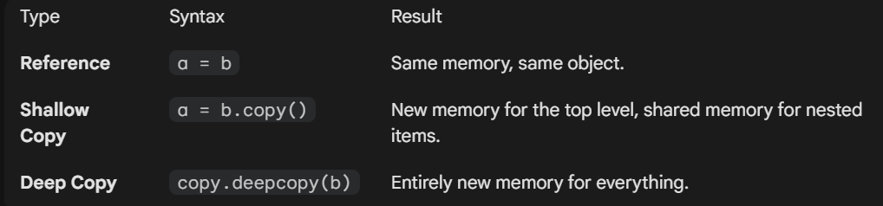
Reference vs Shallow Copy vs Deep Copy — how memory is shared
Copy example in one line each
b = a → same object, same memory. Changing b changes a.
b = a.copy() → shallow copy: new outer object, but nested items are still shared.
b = copy.deepcopy(a) → entirely new memory for everything.

Reference counting in action
The reference count is just "how many names currently point to this object". You can watch it with sys.getrefcount(). Note: getrefcount always shows ONE extra, because passing the object into the function itself creates a temporary reference.
Watching the count rise and fall
import sys

a = [] # the list object now has 1 reference (a)
sys.getrefcount(a) # -> 2 (1 real + 1 from the call itself)

b = a # b points to the SAME list -> 2 references
sys.getrefcount(a) # -> 3

del b # remove one name -> back to 1 reference
sys.getrefcount(a) # -> 2
When the count hits 0, the memory is freed immediately (Layer 1). A reference cycle keeps the count above 0 even when nothing else uses the objects, which is why the garbage collector (Layer 2) exists:
A cycle reference counting alone cannot free
import gc

a = {}
b = {}
a["partner"] = b # a points to b
b["partner"] = a # b points to a -> a cycle

del a, b # names gone, but they still reference each other
# ref counts never reach 0 on their own
gc.collect() # the cyclic garbage collector frees them

Shallow copy — worked examples
A shallow copy makes a NEW outer container, but the items inside are the SAME objects as the original. So changing a top-level item is safe, but changing a NESTED (mutable) item affects both copies.
Flat list — shallow copy behaves like a full copy
original = [1, 2, 3]
shallow = original.copy() # or list(original) or original[:]

shallow[0] = 99 # changes ONLY shallow (top level)
print(original) # [1, 2, 3] -- untouched
print(shallow) # [99, 2, 3]
Nested list — the shared-inner-object trap
import copy

original = [[1, 2], [3, 4]] # a list of lists (nested)
shallow = copy.copy(original) # new outer list, SAME inner lists

shallow[0][0] = 99 # mutates a SHARED inner list
print(original) # [[99, 2], [3, 4]] -- also changed!
print(shallow) # [[99, 2], [3, 4]]

shallow.append([5, 6]) # top-level change -> only shallow
print(original) # [[99, 2], [3, 4]] -- not appended
＋ Added concept: Rule of thumb: shallow copy is fine for FLAT structures (list of numbers/strings). The moment you have nested mutable objects (lists of lists, list of dicts) and you need full independence, use copy.deepcopy().

1.3 Hash Tables (why dictionaries are fast)
A hash table stores data as key–value pairs. Three parts:
- Key: the input (e.g., a username or product ID).
- Hash function: a math formula that turns the key into a specific number (an index).
- Bucket (array): a fixed-size list where the data is actually stored at that index.
Average lookup time complexity is O(1) — constant time. This works because RAM ("Random Access Memory") is built so that accessing ANY memory address takes the same amount of time.
Example
You ask for d["ravi"]. Python hashes "ravi" → gets index 7 → jumps straight to slot 7. It does NOT scan the whole dictionary, which is why dict lookup beats searching a list.

1.4 Multithreading, Multiprocessing & Asyncio

Hardware basics first
- Socket: the physical slot on the motherboard where a CPU (processor) is installed. A computer can have one or more sockets.
- Core: an individual processing unit inside the CPU. Each core executes one task at a time; a multi-core CPU runs multiple tasks truly simultaneously.
Example
2 sockets × 14 cores each = 28 cores → up to 28 independent tasks at the same time (if the software supports it). Lacking CPU → program runs slow. Lacking RAM → program may crash.

CPU-bound vs I/O-bound
- CPU-bound: spends most time computing (e.g., matrix multiplication, image processing).
- I/O-bound: spends most time WAITING for input/output (e.g., reading files, downloading from a website, database calls).

Process vs Thread
- Process: an independent running program with its OWN memory space. Does not share memory with other processes. Heavier, but safer (memory isolation). One process can contain many threads.
- Thread: a smaller unit of execution INSIDE a process. Threads share memory with each other, so they are lighter and faster to create. Best for tasks that wait (I/O).

The GIL (Global Interpreter Lock)
In CPython, the GIL allows only ONE thread to execute Python bytecode at a time, even on multi-core CPUs. So Python threads do NOT speed up CPU-bound work. Python switches threads very fast (default switch interval ≈ 5 ms in Python 3.7–3.10), creating an illusion of parallelism.
- The GIL is temporarily RELEASED when a thread does blocking I/O (reading/writing a file, network call) — so other threads can run while one waits. This is why threads are still useful for I/O-bound tasks.
- Jython and IronPython do not have a GIL.

Multiprocessing
- Each process has its own memory space, its own Python interpreter, and its OWN GIL — so multiprocessing bypasses the GIL and gives TRUE parallel execution on multi-core machines.
- Cost: processes do not share memory by default; sharing data needs special mechanisms (Pipes, Queues) and is slower.
- Inside each process, multiple threads can still exist, but per process only one thread runs Python code at a time.

Asyncio
asyncio lets a SINGLE thread manage many tasks cooperatively — like a task manager that switches to another task whenever the current one is waiting. Use it for waiting-heavy work, not heavy calculation.
- async def → "this function (a coroutine) can be paused and resumed"
- await → "pause here and let other tasks run while we wait"
- asyncio.run() → "start the whole async engine"
Breakfast example (classic)
Eggs take 3 min, pancakes 5 min, coffee 2 min.
Sequential cooking = 3+5+2 = 10 min.
With asyncio.gather(make_eggs(), make_pancakes(), make_coffee()) all three "cook" together → total ≈ 5 min (the longest task), because while one is waiting, the others progress.

Use case | Best tool | Why
Heavy calculation (CPU-bound) | Multiprocessing | Bypasses GIL → true parallelism
Many file/network waits (I/O-bound) | Threading or asyncio | GIL released during I/O / cooperative switching
Thousands of network requests | asyncio | One thread, very low overhead

1.5 Iterables vs Iterators
- Iterable: any object you can loop over — list, tuple, dict, string. It has __iter__() but NOT __next__(). A list is iterable, not an iterator.
- Iterator: an object representing a STREAM of data. It follows lazy evaluation — it does not store the whole collection in memory; it produces the next item only when you ask. Must implement BOTH __iter__() and __next__(). Created with iter(); values pulled with next().
- When an iterator is exhausted, Python raises StopIteration.
Why iterators matter (memory)
numbers = [i for i in range(1_000_000)] → builds a HUGE list in memory.
numbers = range(1_000_000) → an iterator-like object: tiny, constant memory.
File objects are iterators: you can scan a 10 GB log file line-by-line without ever loading it fully into RAM.

from collections.abc import Iterator
isinstance(range(5), Iterator) # False (range is iterable, iter(range(5)) is the iterator)
isinstance(iter([1,2,3]), Iterator) # True
isinstance([1, 2, 3], Iterator) # False
✔ Correction: The original note said isinstance(range(5), Iterator) is True. Actually range is an ITERABLE (lazy, memory-efficient) but technically NOT an Iterator — it has no __next__(). Calling iter(range(5)) gives you the iterator. This exact distinction is a favourite interview trap.
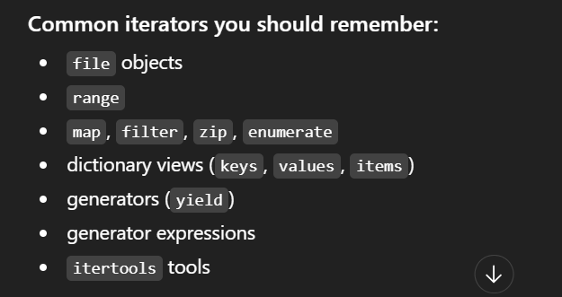
Common iterators/iterable tools worth remembering

1.6 Generators
A generator is a special, easier way to create an iterator. All generators are iterators, but not all iterators are generators. Generators exist because writing iterators by hand (writing __iter__ and __next__ yourself) is painful and error-prone — generators give the same power with far less code.

Two ways to create one
- Generator expression: k = (i for i in range(1, 10)) → note the round brackets (). The generator object k stays tiny and constant in size no matter how big the range is.
- Generator function: any function containing the yield keyword. Calling it does NOT run the code — it returns a generator object.
yield vs return: return kills the function. yield PAUSES it — the function’s state is saved, and when next() is called again it resumes exactly where it left off. When exhausted, it raises StopIteration (same as iterators).
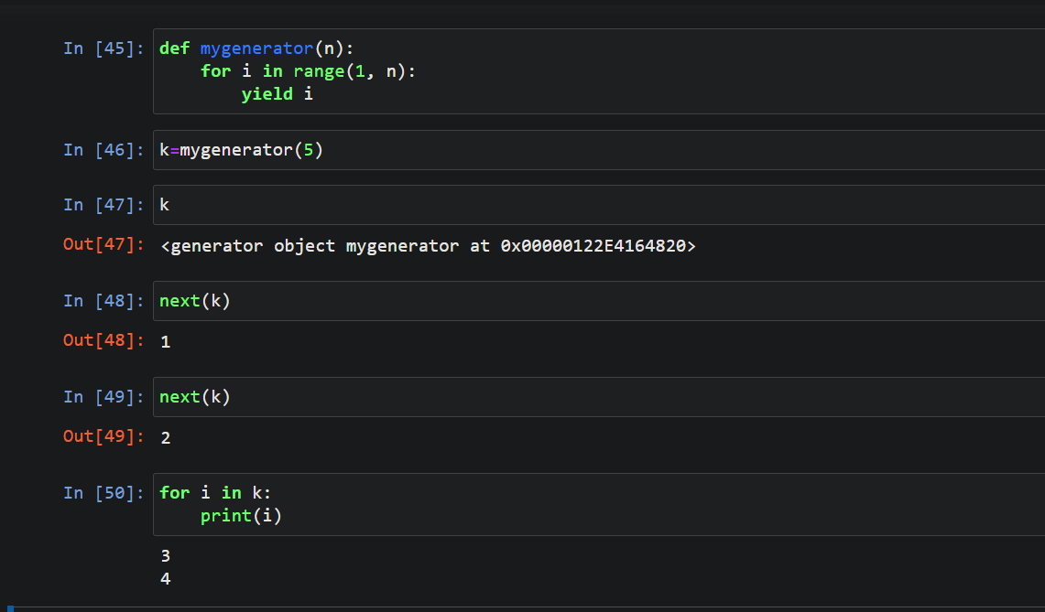
Generator function with yield — created, advanced with next(), then finished with a loop

More generator examples & use cases
Generators shine whenever you want values produced ONE AT A TIME instead of building a whole list in memory. A few common patterns:
Use case 1 — an infinite sequence (impossible with a list)
def count_up(start=0):
n = start
while True: # infinite, but safe
yield n # produces one value, then pauses
n += 1

g = count_up(10)
next(g) # 10
next(g) # 11 # only computes the next value when asked
Use case 2 — Fibonacci, state remembered between yields
def fibonacci():
a, b = 0, 1
while True:
yield a
a, b = b, a + b

f = fibonacci()
[next(f) for _ in range(7)] # [0, 1, 1, 2, 3, 5, 8]
Use case 3 — stream a huge file without loading it all
def read_large_file(path):
with open(path) as fh:
for line in fh: # the file object is itself lazy
yield line.strip() # process line-by-line, never load whole file

for row in read_large_file("huge_log.txt"):
handle(row) # constant memory even for a 50 GB file
Use case 4 — lazy pipeline (each stage pulls from the previous)
# generators chain into a pipeline; nothing runs until consumed
nums = (i for i in range(1, 1_000_000))
squares = (n * n for n in nums) # not computed yet
evens = (s for s in squares if s % 2 == 0)

next(evens) # 4 # only now does the chain pull one value through
Use case 5 — group a stream into fixed-size batches
def batch(iterable, size):
batch_items = []
for item in iterable:
batch_items.append(item)
if len(batch_items) == size:
yield batch_items
batch_items = []
if batch_items:
yield batch_items

for group in batch(range(10), 3):
print(group) # [0,1,2] [3,4,5] [6,7,8] [9]
＋ Added concept: The shared theme: a list builds ALL results up front (high memory, eager); a generator yields results on demand (tiny constant memory, lazy). For data-science pipelines over large datasets, that lazy behaviour is often the difference between fitting in RAM and crashing.

1.7 Decorators
A decorator is a function that takes another function as input and extends its behaviour without modifying its source code. You attach it with @decorator_name above the function definition. Use it when you don’t want to change the function but want to add extra functionality (e.g., measure how long it takes, log calls, validate inputs).

Anatomy
- Outer function: receives the original function.
- Wrapper (inner function): takes the arguments (*args, **kwargs), does extra work, calls the original function, returns the result.
- Return: the outer function returns the wrapper — effectively replacing the original function with a smarter version.
- Stacking: multiple decorators can be applied. The output of the bottom decorator becomes the input of the one above it.
Example — auto-convert string arguments to integers
@convert_to_int_dec
def addition(a, b): return a + b
addition("10.7", "20.2") # decorator converts → 10 + 20 → 30
The decorator pre-processes the arguments (str → float → int) before the real function runs.

1.8 ASCII, Unicode and UTF-8
- ASCII: only 128 characters — English letters, digits, basic symbols.
- Unicode: a global standard assigning a unique number (code point) to EVERY character — 137,000+ including English, Hindi, Chinese, Japanese and emojis. Think of it as a massive ASCII table.
- UTF-8: an ENCODING system for Unicode — it translates any Unicode character into a unique binary string so it can be stored in files. UTF-16 does the same job differently; the two are not compatible with each other.
Why convert bytes (UTF-8) back to Unicode strings? Because humans and Python logic work with characters, not raw bytes.
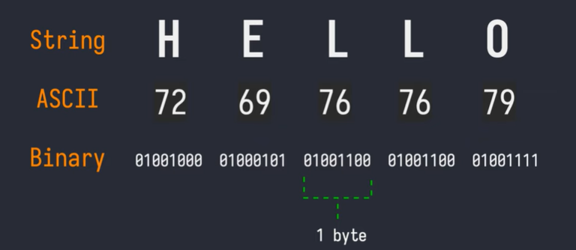
String → ASCII codes → binary: how "HELLO" becomes bytes
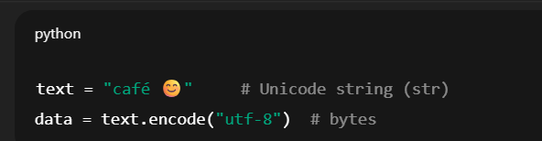
Encoding a Unicode string to UTF-8 bytes in Python

1.9 Regular Expressions — quick reference
Pattern | Meaning
[ ] | character set (any one of these)
[^ ] | NOT these characters
^ / $ | start of string / end of string
. | any character except newline
* / + / ? | 0 or more / 1 or more / 0 or 1
{m,n} | between m and n repetitions
\d / \D | digit / non-digit
\s / \S | whitespace / non-whitespace
\w / \W | word character / non-word character
\b / \B | word boundary / not a word boundary

1.10 Missing Values: NaN vs None
- NaN ("Not a Number"): a missing FLOATING-POINT value. Any arithmetic with NaN gives NaN. Created with float("nan"), math.nan or np.nan. NumPy provides NaN-ignoring aggregations (np.nansum, np.nanmean...).
- None: a Python OBJECT of type NoneType.
- Pandas treats the two nearly interchangeably and automatically converts None to NaN inside numeric columns.
The classic trap
None == None → True
np.nan == np.nan → False! (NaN is never equal to anything, even itself — use pd.isna() / np.isnan() to test)

Tricky Interview Questions — Part 1
Q: Python has a GIL, so threads can’t run in parallel. Why do people still use threading in Python?
Because the GIL is released during blocking I/O. While one thread waits for a file or network response, another thread runs. So threading speeds up I/O-bound programs a lot — it just doesn’t help CPU-bound programs (use multiprocessing for those).
Q: Is Python compiled or interpreted?
Both. Source code is first compiled to bytecode (.pyc), then the Python Virtual Machine interprets that bytecode line-by-line. Saying only "interpreted" is incomplete.
Q: What is the difference between an iterable, an iterator and a generator?
Iterable = can be looped over (has __iter__). Iterator = produces values one at a time with __next__ (lazy stream). Generator = the easy way to BUILD an iterator, using yield or (x for x in ...). Every generator is an iterator; not every iterator is a generator; a list is iterable but neither.
Q: Why does np.nan == np.nan return False?
By the IEEE-754 floating point standard, NaN is defined as not equal to anything, including itself. That is why we must use pd.isna()/np.isnan() instead of == to detect missing values.
Q: If two variables x = 10 and y = 10, are they the same object?
Usually yes — small integers are interned (cached), so both names point to the same memory address. This is an optimization detail of CPython, and it is why "is" can behave surprisingly: use == for value comparison, "is" only for identity.

Part 2 — Core Machine Learning Concepts

2.1 Parametric vs Non-Parametric Models
 | Parametric | Non-Parametric
Number of parameters | Fixed (decided before training) | Flexible (grows with data)
Speed / simplicity | Simple and fast | Can learn complex patterns
Data needed | Less | More
Examples | Linear Regression, Logistic Regression | KNN, Decision Trees, SVM
Example
Linear regression always learns exactly one slope per feature plus one intercept — fixed parameters → parametric. KNN keeps the whole training set and its "shape" grows with the data → non-parametric.

2.2 Lazy Learners vs Eager Learners
- Lazy learner: does NO training upfront — it just stores the training data and computes at prediction time. Training: fast. Prediction: slow. Example: KNN. "It waits until you ask a question, then learns just enough to answer it."
- Eager learner: builds a model during training, then predicts quickly. Training: slow. Prediction: fast. Examples: Decision Trees, Naive Bayes, Neural Networks.

2.3 Generative vs Discriminative Classifiers
- Discriminative ("boundary seekers"): learn the BOUNDARY between classes. They don’t care what makes an apple an apple — only where apples stop and oranges begin. Examples: Logistic Regression, SVM, Decision Trees/Random Forest, traditional Neural Networks.
- Generative ("pattern builders"): learn the DISTRIBUTION of each class — what an apple looks like on its own and what an orange looks like on its own. Examples: Naive Bayes, GANs.

2.4 Bias, Variance, Overfitting & Underfitting
✔ Correction: The original note said "Bias means error of training data, Variance means error of testing data." That is a common but incorrect shortcut. Correct definitions below — this is one of the most frequently mis-answered interview questions.
- Bias: error caused by overly SIMPLE assumptions in the model — the model cannot capture the true pattern even on training data. High bias → underfitting.
- Variance: error caused by the model being too SENSITIVE to the particular training set — a small change in training data produces a very different model. High variance → overfitting.
- How it shows up: overfitting = low TRAINING error but high TEST error (the gap between them is the symptom of high variance). Underfitting = high error on training data itself.
- Trade-off: we want a good balance — neither overfitting nor underfitting. Making a model more complex lowers bias but raises variance, and vice-versa.
Example
Fitting house prices with a straight line when the true relation is curved → high bias (underfit: bad even on training data).
Fitting a degree-15 polynomial through every training point → high variance (overfit: perfect on training, terrible on new houses).

2.5 fit(), transform(), fit_transform() & Data Leakage
- fit() → LEARN parameters (e.g., a scaler learns the mean and std of the training data).
- transform() → APPLY the learned parameters to data.
- fit_transform() → both together, in one step.
Golden rule: NEVER fit on test data. Fit on training data only, then only transform the test data. Fitting on test data lets information from the test set "leak" into the model — this is called data leakage and produces dishonestly good results.
Example
scaler.fit_transform(X_train) ✔ learn mean/std from train and scale train
scaler.transform(X_test) ✔ scale test using the TRAIN statistics
scaler.fit_transform(X_test) ✘ leakage — the model has "seen" the test distribution

2.6 Train/Test Split & Cross-Validation
＋ Added concept: Your notes used train/test ideas everywhere but never defined them — interviewers almost always ask this, so it is added here.
- Train/test split: hold out a portion of data (commonly 20–30%) that the model never sees during training, and measure performance on it. This estimates how the model behaves on genuinely new data.
- K-Fold Cross-Validation: split data into K equal folds (commonly K = 5 or 10). Train on K−1 folds, test on the remaining fold; repeat K times so every fold is tested once; average the K scores. Gives a more stable performance estimate than a single split, especially for small datasets.
- Stratified K-Fold: same idea, but each fold keeps the same class proportions as the full dataset — important for imbalanced classification.
- Leave-One-Out CV (LOOCV): the extreme case where k = number of rows — each fold tests on ONE sample. Nearly unbiased but very expensive and high-variance; used mainly on tiny datasets.
- Time-Series Split: for ordered/time data you must NOT shuffle. Always train on the PAST and validate on the FUTURE (an expanding or rolling window). Random K-Fold here leaks future information into training and inflates the score.
Example (5-fold)
1,000 rows → 5 folds of 200. Round 1: train on folds 2–5, test on fold 1. Round 2: train on 1,3,4,5, test on fold 2 ... Average of the 5 test scores = your reported accuracy.

2.7 Learning Curves & Validation Curves
These two plots are the standard way to DIAGNOSE whether a model is suffering from high bias (underfitting) or high variance (overfitting) — a very common interview follow-up to the bias–variance question.

Learning curve
Plots the training score and the validation score as the TRAINING-SET SIZE grows. It answers "would more data help?"
- High bias (underfitting): both curves settle at a LOW score and sit close together. More data will NOT help — the model is too simple; add features or complexity instead.
- High variance (overfitting): training score stays high, validation score is much lower — a big GAP. More data (or regularization) usually helps here.
- Good fit: both curves converge to a high score with a small gap.

Validation curve
Plots the score against ONE hyperparameter (e.g., tree depth, k in KNN, C in SVM). As the knob increases, you watch under-fitting turn into over-fitting and pick the sweet spot at the peak validation score.
Example
Tuning max_depth of a decision tree: at depth 2 both train and validation accuracy are ~0.70 (underfit). At depth 6 both are ~0.90 (good). At depth 20 train hits 0.99 but validation drops to 0.80 (overfit). Pick depth ≈ 6, where validation peaks.

The two curves side by side
A learning curve changes the AMOUNT OF DATA; a validation curve changes the MODEL COMPLEXITY. Reading them together tells you exactly what to fix.
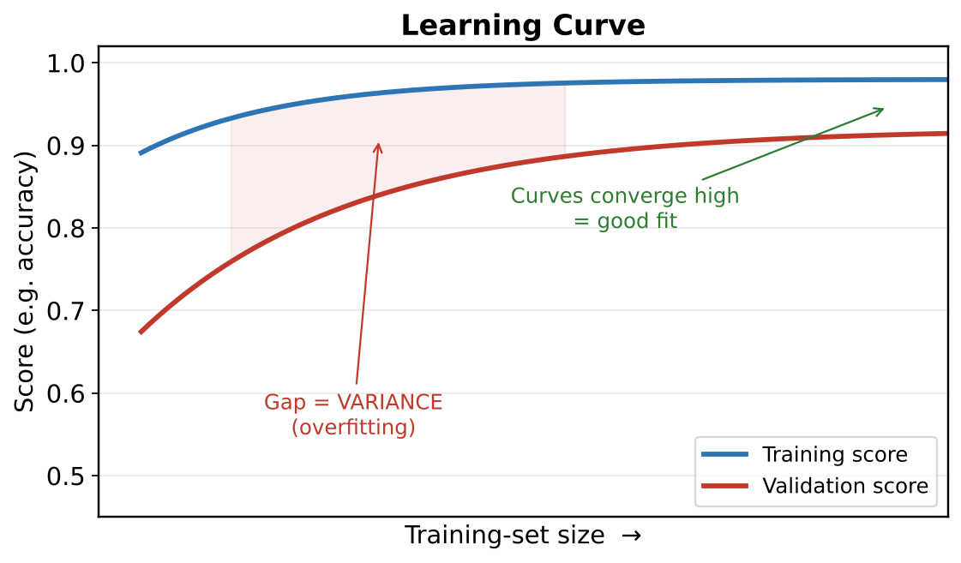
Learning curve: train vs validation score as the training-set size grows
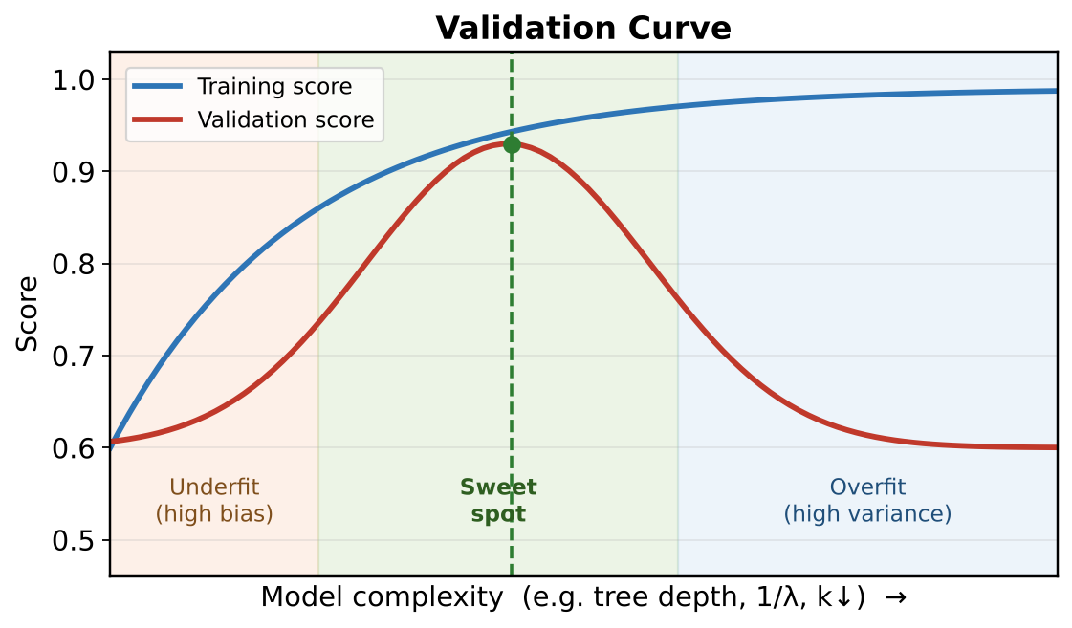
Validation curve: train vs validation score as model complexity grows

Finding the best bias–variance trade-off (with example)
The sweet spot is the model complexity where the VALIDATION score is highest — just before it starts falling. Below it you underfit (high bias); above it you overfit (high variance). The recipe:
- 1. Start simple, get a baseline score on train and validation.
- 2. Increase complexity step by step (deeper tree, more features, smaller regularization) and plot a validation curve.
- 3. Watch the gap: as long as BOTH scores rise, keep going. The moment validation starts dropping while training keeps rising, you have passed the sweet spot — step back.
- 4. Use cross-validation for each setting so the choice is not luck of one split.
Example — tuning a decision tree
depth 2 → train 0.70, val 0.69 (both low → underfit, high bias).
depth 6 → train 0.90, val 0.88 (both high, small gap → GOOD).
depth 12 → train 0.98, val 0.82 (big gap → overfit, high variance).
Pick depth 6 — the peak validation score with the smallest gap.
Example — the knobs that move you each way
More bias (simpler): increase regularization (λ), reduce tree depth, drop features, raise k in KNN.
More variance (complex): decrease regularization, deeper tree, add features, lower k in KNN.
Other fixes: more DATA shrinks variance; better FEATURES shrink bias; ENSEMBLES (bagging) shrink variance.

2.8 Hyperparameter Tuning: Grid, Random & Bayesian
First, the distinction interviewers love: PARAMETERS are learned from data during training (e.g., regression coefficients, tree split points). HYPERPARAMETERS are set BEFORE training and control how learning happens (e.g., learning rate, number of trees, k in KNN, C in SVM). Tuning means searching for the best hyperparameters.
- Grid Search: try EVERY combination on a predefined grid. Simple and thorough, but the cost explodes as you add hyperparameters (the "curse of dimensionality" of tuning) — 5 values across 4 knobs = 625 fits.
- Random Search: sample a fixed number of RANDOM combinations. Often finds a near-best setting far faster, because usually only a FEW hyperparameters really matter and random sampling covers their important values without wasting fits on the rest.
- Bayesian Optimization: build a probabilistic "surrogate" model of how hyperparameters map to score, and use PAST results to choose the next most promising point to try. It converges in far fewer evaluations — ideal when each fit is expensive. Libraries: Optuna, Hyperopt, scikit-optimize.
✔ Correction: Tune hyperparameters using CROSS-VALIDATION, and keep a separate untouched test set for the final estimate. Choosing hyperparameters by peeking at the test set is a form of data leakage — the "right" way is nested CV (an inner loop tunes, an outer loop evaluates).
Method | How it searches | Best when
Grid | every combination | few hyperparameters, small grids
Random | random samples | many hyperparameters, limited budget
Bayesian | learns from past trials | each fit is slow/expensive; want fewest trials

Q: Why does random search often beat grid search with the same budget?
Because performance usually depends on just a couple of the hyperparameters. Grid search wastes many fits varying the ones that don’t matter, while random search spends its budget sampling many different values of the ones that DO — so it covers the important dimension more densely for the same number of fits.

Bayesian optimization in detail (with example)
Grid and random search are "blind" — they never learn from the trials they already ran. Bayesian optimization is "smart": it remembers every (hyperparameter → score) result so far and uses it to decide the NEXT setting most likely to win. That is why it needs far fewer trials when each training run is slow or expensive.
It works in a loop using two pieces:
- Surrogate model: a cheap model (often a Gaussian Process) that predicts the score for any untried hyperparameter, AND how unsure it is about that prediction.
- Acquisition function: a rule that picks the next point to try by balancing EXPLOIT (try near the best-so-far) against EXPLORE (try where the surrogate is very unsure — a surprise might be hiding).
Loop: try a point → get its real score → update the surrogate → let the acquisition function pick the next point → repeat for a fixed budget.
Example — tuning one hyperparameter (learning rate)
Trial 1: lr = 0.001 → accuracy 0.80.
Trial 2: lr = 0.1 → accuracy 0.88.
The surrogate now believes "higher lr looks better, but I have not tried the middle".
Trial 3 (its suggestion): lr = 0.03 → accuracy 0.91 — a smarter pick than a random guess.
Trial 4: it zooms in near 0.03 … converging on the best region in a handful of trials.
- Use when: each training run is expensive (large data, deep models) and you have a small trial budget.
- Skip when: training is very cheap and fast — then plain random search is simpler and parallelizes perfectly (Bayesian trials are partly sequential because each depends on the last).
- Tools: Optuna, Hyperopt, scikit-optimize (and BayesSearchCV).

Tricky Interview Questions — Part 2
Q: A model has 99% training accuracy and 65% test accuracy. Bias problem or variance problem?
Variance (overfitting). The big gap between training and test performance is the signature of high variance. Fixes: more data, regularization, simpler model, ensembling (bagging).
Q: Why must the scaler be fit only on training data?
Because the test set must simulate truly unseen future data. If the scaler’s mean/std include test rows, information about the test distribution leaks into preprocessing, inflating the measured performance — data leakage.
Q: Is KNN training really "free"?
Training is essentially just storing the data (lazy learner) — but you pay at prediction time: each prediction computes distance to ALL training points, which is expensive for large datasets. So "no training cost" does not mean "cheap model".

Q: High bias or high variance — how do you tell them apart from the scores alone?
Compare training vs validation error. BOTH high and close together = high bias (underfitting). Training LOW but validation much higher (big gap) = high variance (overfitting). A tiny gap with both low errors = the good zone.
Q: Your model has 99% training accuracy but 72% test accuracy. What is wrong and what do you do?
That large gap is classic OVERFITTING (high variance). Fixes: add more data, add regularization, simplify the model (shallower tree, fewer features), or use an ensemble like bagging. Do NOT just add complexity.
Q: Both training and test accuracy are stuck at ~65%. Bias or variance problem?
High BIAS (underfitting) — the model is too simple to capture the pattern. Fixes: a more complex model, add/!engineer better features, reduce regularization. More data will NOT help here.
Q: Why is accuracy a misleading metric, and when does that bite you?
On imbalanced data. If 99% of cases are "not fraud", a model that always predicts "not fraud" scores 99% accuracy while catching ZERO fraud. Use precision, recall, F1, or PR-AUC instead when classes are imbalanced.
Q: Can a model underfit and overfit at the same time?
Not overall, but it can per-region: too simple to capture the real trend (bias) yet fitting noise in parts of the data. More usefully: the bias–variance TRADE-OFF means lowering one usually raises the other, so you aim for the balance with the lowest TOTAL error.
Q: Does more data fix underfitting?
No. More data mainly reduces VARIANCE (overfitting). Underfitting is a bias problem — you need a more expressive model or better features, not more rows.
Q: If training accuracy keeps rising but validation accuracy starts falling, what is happening and what do you do?
You have crossed the sweet spot into OVERFITTING. Stop adding complexity: apply early stopping, regularization, or roll back to the simpler setting where validation peaked.
Q: Why can a model with higher training error sometimes be the better model?
Because we care about UNSEEN data. A model that fits training data perfectly often memorized noise (high variance) and generalizes worse. A slightly higher training error with a much smaller train–validation gap usually tests better.

Part 3 — Feature Engineering & Data Preparation
Feature engineering is the process of selecting, manipulating and transforming raw data into features. Fewer, better features reduce complexity and training time; very high dimensions make patterns harder to find.

3.1 Types of Categorical Data & Encoding
- Ordinal data: categories WITH a natural order — e.g., education level (High School < Bachelor < Master < PhD).
- Nominal data: categories WITHOUT any order — e.g., city names, colours.

Encoding techniques
- One-Hot Encoding: one new 0/1 column per category. Use for NOMINAL data. Practical: fine when categories are limited (e.g., fewer than ~50); never replace nominal categories with plain numbers 1, 2, 3 — the model would wrongly learn that 2 > 1.
- Label Encoding: assigns arbitrary integers with no control over order. Risky for input features of linear/distance models (implies fake order), but for the TARGET y in classification it is NOT harmful — the model treats those numbers as class IDs, not magnitudes.
- Ordinal Encoding: integers that respect a meaningful order you define — correct choice for ordinal data.
- MultiLabelBinarizer (sklearn): when one cell holds multiple labels (e.g., a movie tagged "Action, Comedy"), each label becomes its own column: 1 = present, 0 = not present.
Example
City ∈ {Delhi, Mumbai, Pune} → one-hot → Is_Delhi, Is_Mumbai, Is_Pune.
Education ∈ {School, Bachelor, Master} → ordinal → 0, 1, 2 (order is real).
Genres = "Action|Comedy" → MultiLabelBinarizer → Action=1, Comedy=1, Drama=0.

Should the TARGET be one-hot or numeric?
For the target/label (what you predict), the choice depends on the TASK and the LIBRARY, not on the feature rules:
- Classification, classes have NO order (cat/dog/bird, spam/ham): the labels are just names. Most libraries (scikit-learn) want them as plain integer codes (0,1,2) via LabelEncoder — NOT one-hot. The model treats them as separate classes, not as numbers to compare.
- Neural networks / softmax (Keras categorical_crossentropy): here the target IS usually one-hot encoded (e.g., class 2 of 3 → [0,0,1]), because the network outputs one probability per class. (Or keep integers and use sparse_categorical_crossentropy.)
- Ordered classes (low < medium < high): you MAY map to ordered numbers (0,1,2) because the order is real information — ordinal encoding.
- Regression (predicting a price, temperature): the target is already numeric — no encoding at all.
✔ Correction: One-hot is mainly a FEATURE technique to avoid inventing a fake order among input categories. For a nominal TARGET in classic ML, integer class codes are correct — the algorithm never does arithmetic on the label, it only checks "which class". Reserve one-hot targets for softmax/neural-network setups.
Quick guide
Nominal target + scikit-learn model → integer codes (LabelEncoder).
Target for a softmax neural net → one-hot (or sparse labels).
Ordinal target (ratings) → ordered integers.
Numeric target (regression) → leave as-is.

3.2 The Dummy Variable Trap
After one-hot encoding, one dummy column can be PERFECTLY predicted from the others. Example with two categories Dog/Cat: if Is_Dog = 0 you know with 100% certainty Is_Cat = 1 — they are perfectly correlated. This creates perfect multicollinearity, which breaks the math of linear models.
Escape: the n−1 rule. Always drop one dummy column (e.g., drop Is_Cat; "both zeros" then means Cat). In pandas: pd.get_dummies(df, drop_first=True).

3.3 Feature Scaling — who needs it and who doesn’t
- MUST scale: gradient-descent-based models (Logistic Regression, Neural Networks) and distance-based models (KNN, K-Means, SVM). Otherwise a feature like salary (in lakhs) totally dominates a feature like age.
- NO need to scale: tree-based models (Decision Tree, Random Forest, Gradient Boosting). Trees only ask "is feature > threshold?" — the answer doesn’t change if you rescale.
＋ Added concept: The two standard scaling methods (worth naming explicitly in interviews): Standardization (StandardScaler): z = (x − mean)/std → mean 0, std 1; not bounded; less hurt by outliers than min-max. Normalization (MinMaxScaler): (x − min)/(max − min) → squeezes into [0, 1]; very sensitive to outliers. RobustScaler uses median and IQR, so it is the safest when outliers are present.

Min-Max vs Standardization — when each works, and how distribution matters
Both rescale features, but they react very differently to the shape of your data (its distribution) and to outliers.

Min-Max scaling (Normalization)
Formula: x′ = (x − min) / (max − min). Squeezes every value into a fixed range, usually [0, 1].
- Use it when: you need a bounded range (image pixels 0–255 → 0–1), the data has NO heavy outliers, or an algorithm expects [0,1] inputs (some neural nets, distance/KNN with known bounds).
- Do NOT use it when: there are OUTLIERS. The min and max are set by the two most extreme points, so one huge value crushes all the normal points into a tiny sub-range. Example: incomes [20k, 25k, 30k, 1,000k] → the first three all land near 0.00–0.01 and become indistinguishable.
- Distribution effect: Min-Max does NOT change the SHAPE of the distribution — a skewed histogram stays skewed, just rescaled. It only moves and stretches the axis.

Standardization (Z-score)
Formula: x′ = (x − mean) / standard deviation. Centres the data at 0 with a spread of 1. Values are NOT bounded (can be −3, +5, etc.).
- Use it when: the feature is roughly BELL-SHAPED (Gaussian), or the algorithm assumes centred data — linear/logistic regression, SVM, PCA, k-means. It is the safer default for most ML.
- Do NOT rely on it when: the data is far from normal AND full of outliers — the mean and standard deviation are themselves pulled by the outliers, so the "standardized" values are distorted.
- Distribution effect: Standardization also keeps the SHAPE — it does not make a skewed feature normal. If you truly need a more normal shape, transform first (log, Box-Cox, Yeo-Johnson), THEN standardize.
＋ Added concept: Neither Min-Max nor Z-score makes data "normal"; they only shift/scale it. To fix SKEW you need a transform (log/Box-Cox). Tree-based models (Decision Tree, Random Forest, XGBoost) need NO scaling at all — they split on thresholds, which rescaling never changes.

RobustScaler — the outlier-proof option (in detail)
Formula: x′ = (x − median) / IQR, where IQR = Q3 − Q1 (the middle 50% spread). It uses the MEDIAN and IQR instead of mean and standard deviation — and both of those ignore the extreme tails, so outliers barely move them.
- Why it is robust: the median does not care about a few giant values, and the IQR is measured from the 25th to 75th percentile, so the outliers sitting beyond them do not affect the scale.
- Use it when: the feature has outliers you cannot remove (income, transaction amount, sensor spikes) but you still want scaled inputs for a distance- or gradient-based model.
Example — income [20, 25, 30, 35, 1000] (in thousands)
Min-Max: max is 1000, so 20–35 all squash into ~0.000–0.015 — the normal people become indistinguishable.
Z-score: the mean (222) and std (430) are dragged up by 1000, so normal incomes map to about −0.47 and the outlier dominates.
RobustScaler: median = 30, IQR = Q3−Q1 = 35−25 = 10. 20 → (20−30)/10 = −1.0, 25 → −0.5, 35 → +0.5, and 1000 → +97 (clearly flagged as extreme) while the normal values stay nicely spread across −1…+0.5.
So RobustScaler keeps the ordinary points well separated AND still exposes the outlier as a large value, instead of letting the outlier squash everyone else.
Scaler | Uses | Range | Outliers | Best for
Min-Max | min & max | [0,1] fixed | very sensitive | bounded data, no outliers
Z-score | mean & std | unbounded | sensitive | bell-shaped data, general ML default
Robust | median & IQR | unbounded | resistant | data with outliers

Worked scenario: scaling 3 columns on very different ranges
The problem: a DataFrame with 50,000 rows and 3 numeric columns on wildly different scales — Column A ranges 100 to 1,00,00,000 (1 crore), Column B ranges 1 to 500, Column C ranges 1 to 10. The data is NOT normally distributed and (first case) has NO outliers. How do you scale it for ML?
Why scaling is needed here: for distance- or gradient-based models (KNN, K-Means, SVM, Logistic/Linear Regression, neural nets), Column A’s huge numbers would completely dominate Columns B and C — the model would behave as if only Column A exists. Scaling puts all three on a comparable footing. (Tree-based models — Decision Tree, Random Forest, XGBoost — need NO scaling at all; skip this step for them.)

Case 1 — NO outliers: use Min-Max (Normalization)
Recommended: Min-Max scaling to [0, 1]. x′ = (x − min) / (max − min), applied PER COLUMN. Why Min-Max here:
- No outliers → safe: Min-Max’s only weakness is outliers (they set min/max). With none, it maps every column cleanly onto [0,1].
- Distribution shape does not matter: Min-Max does not assume normality — it just rescales the axis. So "not normally distributed" is fine; you do NOT need Gaussian data for Min-Max.
- All columns end on the same range: A, B and C each become 0–1, so none dominates by sheer magnitude.
Case 1 — Min-Max
from sklearn.preprocessing import MinMaxScaler
scaler = MinMaxScaler() # default range [0, 1]
X_train_scaled = scaler.fit_transform(X_train) # fit on TRAIN only
X_test_scaled = scaler.transform(X_test) # reuse train min/max
What each column becomes (Case 1)
Column A: 100 → 0.0, 1 crore → 1.0, a mid value 50,00,000 → ~0.5.
Column B: 1 → 0.0, 500 → 1.0.
Column C: 1 → 0.0, 10 → 1.0.
Now all three live on 0–1, so Column A no longer overpowers B and C.
＋ Added concept: Standardization (Z-score) would ALSO work here and is a fine default, but it does not bound the output to a fixed range and it is slightly more associated with bell-shaped data. Since the data has no outliers and you may want a fixed [0,1] range, Min-Max is the clean choice. Either one is acceptable in an interview — just justify it.

Case 2 — Outlier in Column A: use RobustScaler
Recommended: RobustScaler for the columns with outliers (at least Column A). x′ = (x − median) / IQR, where IQR = Q3 − Q1. The median and IQR ignore the extreme tails, so one giant value in Column A barely moves them.
- Why NOT Min-Max now: a single huge outlier becomes the max, so all the normal values get squashed into a tiny sub-range near 0 and become indistinguishable.
- Why NOT plain Z-score now: the mean and standard deviation are themselves dragged by the outlier, so "standardized" normal values get distorted and the outlier still dominates.
Case 2 — RobustScaler
from sklearn.preprocessing import RobustScaler
scaler = RobustScaler() # uses median & IQR
X_train_scaled = scaler.fit_transform(X_train)
X_test_scaled = scaler.transform(X_test)
Min-Max vs Robust on an outlier (Column A = [100, 5000, 20000, 50000, 1 crore])
Min-Max: the normal values 100–50000 all collapse to ~0.000–0.005, while only the 1-crore outlier reaches 1.0 → normal rows become indistinguishable.
RobustScaler: median = 20000, IQR = 45000. So 100 → −0.44, 5000 → −0.33, 50000 → +0.67, and the 1-crore outlier → ~+222 (clearly flagged as extreme) — the normal rows stay nicely spread between −1 and +1.
- Practical tip: you can mix scalers per column — RobustScaler on Column A (has the outlier) and Min-Max/Standard on B and C — using a ColumnTransformer. Or RobustScaler on all three; it is safe even on columns without outliers.
Optional — different scaler per column
from sklearn.compose import ColumnTransformer
from sklearn.preprocessing import RobustScaler, MinMaxScaler
ct = ColumnTransformer([
("A", RobustScaler(), ["col_A"]), # outlier column
("BC", MinMaxScaler(), ["col_B","col_C"]),
])
X_train_scaled = ct.fit_transform(X_train)
✔ Correction: Whichever scaler you choose, always FIT on the training set only and then TRANSFORM train and test with those same parameters. Fitting the scaler on the whole dataset (before the split) leaks test information and inflates your score. Put the scaler inside a Pipeline so cross-validation does this correctly.

Does scaling change the correlation between columns?
No — and this is a favourite interview point. Min-Max and Standardization (and RobustScaler) are LINEAR, monotonic transforms: new = (old − a) / b. Pearson correlation measures the LINEAR relationship and is invariant to shifting and positive rescaling, so the correlation between any two columns is EXACTLY the same before and after scaling.
Verified on 50,000 rows (this scenario)
corr(A, B): before = 0.1922, after Min-Max = 0.1922, after Z-score = 0.1922.
corr(A, C): before = 0.0083, after Min-Max = 0.0083, after Z-score = 0.0083.
Identical to many decimal places — scaling only changes each column’s units, not how two columns move together.
- Why: correlation already divides by each variable’s standard deviation, so it is "scale-free". Multiplying a column by a constant or shifting it cancels out in the formula.
- Small caveats: the correlation stays the same only for a POSITIVE linear scaling (all standard scalers are). A NON-linear transform (log, Box-Cox, square-root) WOULD change correlation, because it bends the relationship — that is a transform, not plain scaling. Also, multiplying a column by a NEGATIVE number would flip the sign (scalers never do this).
＋ Added concept: So: scale to stop big-range columns from dominating distance/gradient models; it will NOT distort the relationships between your features. If you instead want to fix SKEW (not range), use a log/Box-Cox transform — but know that it WILL change correlations.
Q: Data is not normally distributed — can you still use Min-Max or Standardization?
Yes. Neither assumes a normal distribution; they only shift and rescale the axis and do NOT change the shape of the histogram. Normality is not a requirement for scaling. If you specifically need a more normal shape, that is a separate step (log/Box-Cox transform), not scaling.
Q: One column is 100–1 crore and another is 1–10. If you skip scaling, what breaks?
Distance- and gradient-based models (KNN, K-Means, SVM, linear/logistic regression, neural nets) will be dominated by the 1-crore column — distances and gradients are driven almost entirely by it, so the 1–10 column is effectively ignored. Tree-based models would be unaffected.
Q: Does scaling change feature correlation or feature importance ordering?
Scaling does NOT change Pearson correlation (linear, monotonic transform). It also does not change tree-based split decisions or their importance ranking. It CAN change the coefficients of linear models (which is exactly why you scale them — to compare coefficients fairly).

3.4 Handling Imbalanced Datasets
Drawback of imbalance: the model becomes biased toward the majority class and accuracy becomes misleading (a model predicting "not fraud" for everyone gets 99% accuracy on a 1%-fraud dataset).

1) Under-sampling — Condensed Nearest Neighbour (CNN)
✔ Correction: CNN here means Condensed Nearest Neighbour — NOT Convolutional Neural Network. Same acronym, completely different thing; say the full name in interviews.
CNN removes majority-class rows in a way that loses minimal information:
- Step 1: put ALL minority samples in the condensed set C, plus one (or a few) random majority samples.
- Step 2: for every remaining point, classify it using its nearest neighbour in C (1-NN). Correctly classified → ignore it (redundant). Misclassified → add it to C (it carries boundary information).
- Repeat until no new points need to be added.

Condensed Nearest Neighbour — a worked example
The goal of CNN is to throw away majority-class rows that sit deep inside their own cluster (they add nothing) while KEEPING the rows near the decision boundary (they matter). It does this by repeatedly testing each point with a 1-Nearest-Neighbour rule against a small "condensed set" C.
Imagine a fraud problem: O = legitimate (majority), X = fraud (minority).
Step-by-step
Data: 20 legitimate (O) and 3 fraud (X). Most O’s are clustered far from any fraud; a few O’s sit right beside the fraud cases.
Start: C = all 3 fraud points + 1 random legitimate point. (Minority always kept in full.)
Pass through every remaining O: classify it by its nearest neighbour already in C.
• An O deep in the legitimate cluster → its nearest neighbour in C is the legitimate point → predicted O → CORRECT → discard it (redundant).
• An O sitting next to a fraud point → its nearest neighbour in C might be a fraud X → predicted X → WRONG → add this O to C (it defines the boundary).
Repeat: keep sweeping until a full pass adds nothing new.
Result: C now holds all 3 fraud points plus only the handful of legitimate points hugging the boundary — maybe 5 O’s instead of 20. The other 15 redundant O’s are dropped.
- Why it works: the points a 1-NN classifier gets right are exactly the ones it does not need to "see" — they are surrounded by their own kind. The points it gets wrong sit on the boundary and carry the information that separates the classes.
- Trade-off: CNN is sensitive to noise (a mislabelled point near the boundary gets kept and can distort it) and the result depends on the random starting point, so different runs can keep slightly different sets.

CNN in detail — simple example with diagram
Remember: here CNN = Condensed Nearest Neighbour (an under-sampling method), NOT the deep-learning Convolutional Neural Network. Its job: shrink the big majority class by KEEPING only the majority points that sit near the boundary with the minority class, and THROWING AWAY the ones buried deep inside the majority cloud (they add nothing a classifier needs).
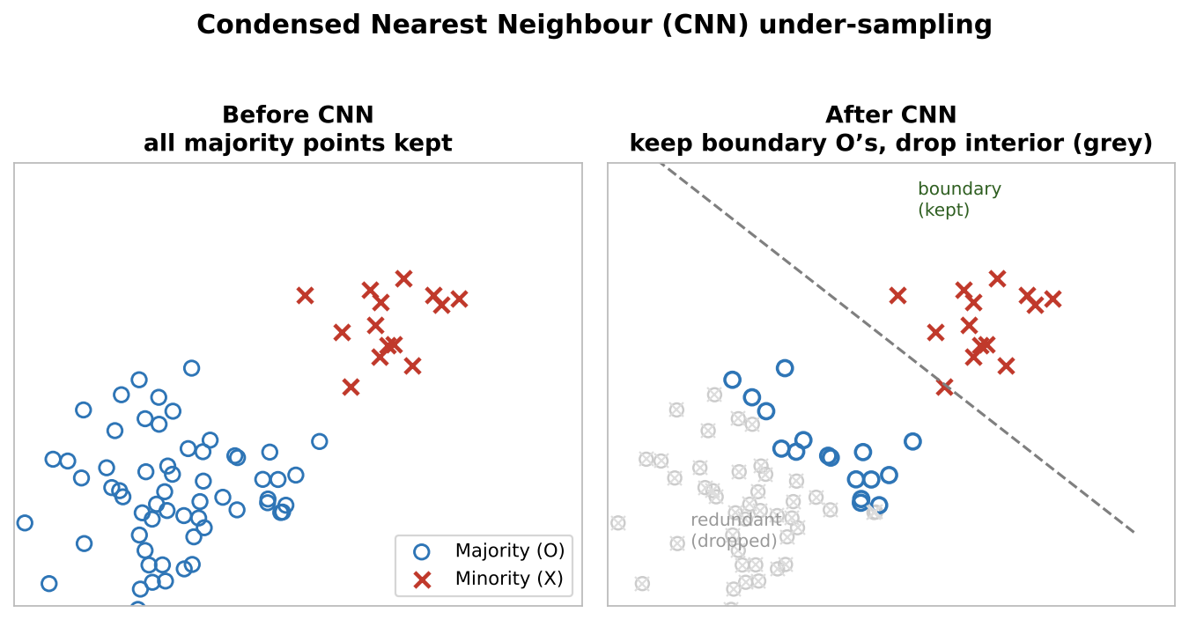
CNN keeps the boundary majority points and drops the redundant interior ones
Simple idea in one line: a point is REDUNDANT if a 1-nearest-neighbour rule already classifies it correctly from the points we are keeping; it is USEFUL if that rule gets it wrong (so it must sit near the boundary).
Simple example
Imagine 100 "legit" transactions (O) and 5 "fraud" (X). Most O’s are clustered far away from any fraud; a few O’s sit right next to the fraud cases.
Start the kept-set with the 5 fraud points + 1 random legit point.
Test each remaining O with its nearest kept neighbour: an O deep inside the legit cloud → nearest kept point is also legit → predicted correctly → DROP it (redundant).
An O sitting beside a fraud point → its nearest kept point might be a fraud X → predicted wrong → KEEP it (it defines the border).
Result: maybe 100 O’s shrink to ~15 — the ones hugging the boundary — while all 5 fraud stay. The boundary is preserved with far less majority data.
- Why keep only the border? the decision boundary is decided by the points NEAR it. Interior majority points are "obvious" and removing them does not move the boundary, but it does balance the classes.
- Watch out: CNN is sensitive to noise (a mislabelled point near the border gets kept and can distort the boundary) and the result depends on the random starting point.

2) Over-sampling — SMOTE
SMOTE (Synthetic Minority Oversampling Technique) creates NEW synthetic minority points instead of copying existing ones:
- Pick a minority sample; find its k nearest minority neighbours.
- Pick one neighbour; compute the vector between the two points.
- Multiply that vector by a random number between 0 and 1, and add it to the original point → a new synthetic point somewhere on the line between them.
Advantage: no duplicates — synthetic points are slightly different from the originals. Weakness: standard SMOTE blindly generates points for EVERY minority sample, even outliers/noise.
Tiny SMOTE example
Minority points A=(2,2) and neighbour B=(4,4). Vector = (2,2). Random factor 0.5 → synthetic point = (2,2) + 0.5×(2,2) = (3,3) — a new "in-between" fraud-like example.

MSMOTE (Modified SMOTE)
- First classifies minority samples into 3 groups using distances: Security/Safe samples, Border samples, and Latent-noise samples.
- Then: for safe samples it picks a random point among the k nearest neighbours; for border samples it picks the NEAREST neighbour; for noise samples it does NOTHING (no synthesis from noise).

SMOTE in detail
SMOTE does not duplicate minority rows (which would just make the model memorize them); it INVENTS new, plausible minority rows that lie between real ones. The recipe for one synthetic point:
- 1. Pick a real minority sample x.
- 2. Find its k nearest minority neighbours (default k = 5). Randomly choose one of them, call it x_neighbour.
- 3. Form the difference vector: diff = x_neighbour − x.
- 4. Draw a random number λ between 0 and 1.
- 5. New point = x + λ × diff — it lands somewhere on the straight line connecting the two real points.
Repeat until the minority class reaches the size you want.
Worked example (2-D)
Real minority point: x = (2, 2). Its chosen neighbour: x_neighbour = (4, 6).
diff = (4, 6) − (2, 2) = (2, 4).
λ = 0.5 → new = (2, 2) + 0.5×(2, 4) = (3, 4).
λ = 0.25 → new = (2, 2) + 0.25×(2, 4) = (2.5, 3).
Every λ gives a different, realistic point on the segment between two genuine fraud cases.
- Strength: expands the minority region smoothly instead of stacking duplicates, so the classifier learns a fuller picture of the minority class.
- Weakness: plain SMOTE treats every minority point equally. If a minority point is actually noise sitting inside the majority cloud, SMOTE will happily generate MORE noise around it, blurring the boundary.
- Useful variants: Borderline-SMOTE only synthesizes near the decision boundary (where it helps most); SMOTE-NC handles mixed numeric + categorical features; ADASYN generates more points for the minority samples that are hardest to learn.
✔ Correction: Apply SMOTE only on the TRAINING fold, AFTER splitting (or inside a cross-validation pipeline) — never before the split. Oversampling first lets synthetic points built from test rows leak into training, giving a falsely high score. This is one of the most common interview "gotchas".

MSMOTE (Modified SMOTE) in detail
MSMOTE fixes plain SMOTE’s blindness by first deciding WHAT KIND of minority point each one is, then treating each kind differently. For every minority sample it looks at its k nearest neighbours (across all classes) and labels it:
- Safe / security sample: most of its neighbours are also minority → it sits comfortably inside the minority region.
- Border sample: its neighbours are a mix of both classes → it sits on the decision boundary.
- Latent-noise sample: most/all of its neighbours are majority → it is probably noise lying inside majority territory.
Then it generates synthetic points using a different rule for each type:
- Safe → pick any one of the k nearest neighbours at random (same as normal SMOTE) — safe to interpolate widely here.
- Border → pick the NEAREST neighbour only — stay close so new points do not cross into the majority side.
- Noise → generate NOTHING — refuse to amplify noise.
＋ Added concept: The whole idea: SMOTE asks "where can I add points?"; MSMOTE asks "where is it SAFE to add points, and where should I hold back?" — giving cleaner boundaries on noisy data.

When SMOTE CAN and CANNOT be used
SMOTE invents new minority points by interpolating BETWEEN real minority neighbours. That trick helps in some settings and backfires in others.
- CAN use when: the minority class forms reasonably tight clusters, features are CONTINUOUS/numeric, classes are moderately imbalanced, and the minority points are mostly clean (not noise). Then the "in-between" points are realistic.
- CANNOT / should not use when:
- • Categorical features: averaging two categories (e.g., "red" and "blue") is meaningless. Use SMOTE-NC for mixed data, or a different method.
- • Overlapping classes: if minority and majority points are mixed together, the synthetic points land inside majority territory and CREATE noise, blurring the boundary.
- • High-dimensional data: "nearest neighbour" becomes unreliable when there are very many features (curse of dimensionality), so the synthetic points may not represent the real minority.
- • Noisy or mislabelled minority points: SMOTE will faithfully generate MORE points around the noise, amplifying the error (MSMOTE or Borderline-SMOTE handle this better).
- • Extreme imbalance (e.g., 1 in 100,000): too few real minority points to interpolate meaningfully; combine with under-sampling or use anomaly-detection framing instead.
✔ Correction: Always apply SMOTE on the TRAINING fold only, AFTER the train/test split (ideally inside a CV pipeline). Oversampling before the split lets synthetic points built from test rows leak into training and gives a falsely high score — the classic SMOTE mistake.

3) Cost-Sensitive Learning
Instead of changing the data, change the algorithm: increase the cost (penalty) of mistakes on the minority class — e.g., class_weight="balanced" in sklearn. A false negative on fraud can be made 100× more "expensive" than a false positive.

When NOT to use under/over-sampling
- Overlapping classes: if minority and majority points are mixed together in feature space, synthetic points land inside the majority region and make things worse.
- High dimensions: "nearest neighbour" becomes unreliable (curse of dimensionality — points become sparse and far apart), so SMOTE’s synthetic samples may not represent the minority class well.
- Multiclass: SMOTE can still be used (applied per class). Multilabel: NO — standard SMOTE assumes each sample has exactly one label.
＋ Added concept: Practical rule interviewers love: apply SMOTE/under-sampling AFTER the train/test split, and only on the TRAINING set. Resampling before the split leaks synthetic copies of test information into training.

3.5 Distance Metrics in ML
- Euclidean: the straight-line (shortest) distance between two points. Best for low-dimensional data. Example: between (0,0) and (3,4) → √(9+16) = 5.
- Manhattan: distance moving only horizontally and vertically — no diagonals (like city blocks). Same points → |3| + |4| = 7.
- Cosine: measures the ANGLE between two vectors, ignoring magnitude. Used to compare documents by term frequencies: a short article and a long article about the same topic point in the same direction → high similarity. Derived from the dot product.
- Hamming: number of positions where two equal-length strings differ. "karol" vs "kerol" → 1. Only works for same-length strings; larger distance = more dissimilar.
- Chebyshev: the GREATEST difference along any single coordinate. Between (1,1) and (4,3) → max(3, 2) = 3 (the "king’s move" distance in chess).

3.6 Feature Selection

A) Filter methods (look at data quality, not at any model)
- Variance threshold: remove features whose variance is below a threshold — by default, zero-variance features (same value in every row carry no information). Also drop one of any pair of HIGHLY correlated features (they explain the same information).
- Univariate selection: score each feature’s relationship with the target and keep the strongest, using statistical tests: Mutual Information, Chi-square, ANOVA.

Mutual Information (MI)
- Measures how much knowing one variable tells you about another. Handles both categorical and continuous variables.
- Score range: 0 to ∞. Higher = stronger connection between feature and target. 0 = independent.
- No universal cutoff — common practice: keep MI > 0.01, or keep the top-k features, or try several thresholds and compare model accuracy / F1.

Chi-square test
Used to test the independence of two events — strictly for CATEGORICAL variables. The higher the chi-square value, the more the feature depends on the target → more useful. Output: a test statistic and a p-value.
Background: if Z₁,...,Zₖ are independent standard normal variables, the sum of their squares follows a chi-squared distribution with k degrees of freedom:

Chi-square distribution: sum of squared standard normal variables

Intuition behind Mutual Information & Chi-square
Both answer "does this feature tell me something about the target?" — but in different ways and for different data types.
- Mutual Information — "how much does knowing X reduce my surprise about Y?" If knowing a feature makes the target much more predictable, MI is high; if the feature tells you nothing, MI = 0. It captures ANY relationship (even non-linear, unlike correlation).
MI example
Target: will it rain? Feature "umbrella sales": when sales are high it almost always rains, when low it rarely does → knowing sales sharply cuts your uncertainty → HIGH MI.
Feature "shirt colour": rain happens equally across all colours → knowing colour changes nothing → MI ≈ 0.
- Chi-square — "are feature and target INDEPENDENT, or do they move together more than chance?" It compares the counts you actually observe with the counts you would EXPECT if the two were unrelated. A big gap between observed and expected → big chi-square → they are related → useful feature. (For categorical feature vs categorical target.)
Chi-square example
Feature "gender" vs target "buys product". If buyers split 50/50 across genders exactly as the overall ratio predicts → observed ≈ expected → chi-square ≈ 0 → gender is irrelevant.
If 80% of buyers are one gender when only 50% of people are → observed ≫ expected → large chi-square → gender matters.
＋ Added concept: One-line intuition: Mutual Information measures shared information (uncertainty removed); Chi-square measures how far reality is from "no relationship". MI works for numeric and categorical and non-linear links; Chi-square is for categorical counts and needs non-negative values.

B) Recursive Feature Elimination (RFE)
- Train the chosen model on ALL features; rank features by the model’s importance scores.
- Remove the least important feature(s); re-train; repeat until the desired number of features remains.
- Key point: RFE has NO importance measure of its own — it borrows whatever importance the wrapped model provides (coefficients, tree importance...).

C) Model-based feature importance
- Linear / Logistic Regression: importance from coefficient magnitude (on scaled features).
- Decision Tree: tracks how much each feature improves purity every time it is used to split — features that create purer groups are important.
- Random Forest: each tree computes importance; importances are averaged across trees.
- Gradient boosting (XGBoost/LightGBM/CatBoost): three separate metrics — Gain (error reduction, most commonly used), Frequency (number of splits using the feature), Cover (number of samples affected). You choose which one to judge by.

Feature selection with a multi-class target
Most filter scores were described above for a single target, but they all extend to a target with more than two classes — you just use the multi-class version of the test. The key shift in thinking: a feature can be useless for separating classes A and B yet crucial for spotting class C, so "importance" becomes per-class as much as global.
- ANOVA F-test (f_classif): for numeric features vs a categorical target with many classes, it asks "do the class means differ?" across ALL classes at once — works natively for multi-class.
- Mutual Information (mutual_info_classif): measures shared information between a feature and the multi-class label directly; no binary assumption, handles non-linear relationships.
- Chi-square (chi2): for non-negative/categorical features against a multi-class label; computed over the full class-by-feature contingency table.
- One-vs-Rest view: to see WHICH class a feature helps with, score it separately for each class framed as "this class vs all others". A feature with a huge score for one class but near-zero for the rest is a specialist — keep it even if its overall score looks modest.
- Wrapper / model-based: RFE and tree/forest importances work with multi-class out of the box, as long as the wrapped estimator is multi-class capable (most are). The importance is naturally aggregated across all classes.
Example
Classifying transactions as {normal, card-testing, account-takeover}. The feature "many tiny transactions per minute" barely separates normal from account-takeover, but is decisive for card-testing. A global score might rank it mid-table; a per-class (OvR) score reveals it is a top feature for ONE class — so you keep it.

How a decision tree decides which features are important
A decision tree assigns importance by measuring how much each feature REDUCES IMPURITY (Gini or entropy) across all the splits where it is used. More purity gained = more important.
For a single split, the impurity decrease is:
decrease = impurity(parent)
- (n_left/n) * impurity(left child)
- (n_right/n) * impurity(right child)
Each split’s decrease is WEIGHTED by the fraction of samples that reach that node (a split near the root affects many rows and counts more than a split deep in a rare branch). A feature’s importance is the SUM of these weighted decreases over every node where it splits, and finally all importances are normalized to add up to 1.
Mini example
Root: 100 samples, Gini = 0.5. Split on "amount > 1000" sends 40 left (Gini 0.1) and 60 right (Gini 0.2).
Decrease = 0.5 − (40/100)(0.1) − (60/100)(0.2) = 0.5 − 0.04 − 0.12 = 0.34.
Weighted by 100/100 = 1 (it is the root) → this split contributes 0.34 to the importance of "amount".
Add up every split that uses "amount", do the same for every other feature, normalize → the importance ranking.
- In a Random Forest: each tree computes these importances and they are AVERAGED across all trees, which makes the ranking far more stable than any single tree.
✔ Correction: Impurity-based importance is BIASED toward high-cardinality features (columns with many distinct values, like IDs or continuous variables) because they offer more places to split. For a more trustworthy ranking, use PERMUTATION importance — shuffle one feature’s values and measure how much the model’s score drops; a big drop means the feature truly mattered.

Rare categories: "other" vs remove (especially on imbalanced data)
Sometimes a CATEGORICAL feature has values that appear only once, twice, or a handful of times (e.g., a "merchant_city" with 2,000 cities, many seen just once). These rare levels cause trouble: one-hot encoding explodes into thousands of near-empty columns, the model can memorize a single row (overfitting), and on imbalanced data a rare level may line up with the rare class purely by chance.
The usual choices, and when to pick each:
- Group into "Other": merge all low-frequency levels into a single bucket (e.g., any city seen < 20 times → "Other"). This is the DEFAULT choice — it keeps the information "this was a rare city" without 2,000 columns, and stays robust on new unseen values at prediction time.
- Remove the level / rows: only if the level is clearly noise, a typo, or truly meaningless. Dropping rows is risky on imbalanced data — you might delete precious minority examples.
- Drop the whole feature: if almost EVERY value is unique (like a raw ID or free-text), the column is near-useless for the model — either drop it or engineer something from it (e.g., count of transactions per ID).
- Frequency / target encoding instead of one-hot: replace each category with how often it appears (frequency encoding) or the mean target for that category (target encoding, computed on training folds only). This handles thousands of levels without exploding columns.
✔ Correction: On imbalanced data, be extra careful: a category that appears 3 times and all 3 are the rare (fraud) class looks hugely predictive but is just coincidence (it will not generalize). Grouping into "Other" or using smoothed target encoding (with a prior) prevents the model from trusting these flukes. Decide the cutoff on the TRAINING set only, and map unseen test values to "Other".
Example
merchant_city has 2,000 values; 1,700 appear < 10 times.
Bad: one-hot → 2,000 columns, most all-zeros → overfitting + slow.
Good: keep the top ~50 cities, map the rest to "Other" → ~51 columns, generalizes, and a brand-new city at prediction time safely falls into "Other".
Alternative: frequency-encode → one numeric column = how common that city is.

Do feature-selection methods need numbers / scaling first?
Two different questions people mix up: (1) does the method need categories turned into NUMBERS (encoding)? and (2) does it need feature SCALING (Min-Max / standardization)? The answers differ by method.

Which methods need categories converted to numbers
- Chi-square (chi2): needs CATEGORICAL inputs as non-negative counts/codes. Continuous features must be binned into categories first; categorical features are label/ordinal-encoded to non-negative integers. It cannot take negative values — so NO standardization (which creates negatives) before chi2.
- Correlation (Pearson): needs NUMERIC inputs. Categorical features must be encoded first (or use Cramer’s V for categorical-vs-categorical).
- Mutual Information (mutual_info_classif/regression): works with numeric inputs, BUT you tell it which columns are discrete via discrete_features. Categoricals should be integer-encoded and flagged discrete; it does NOT need one-hot.
- ANOVA F-test (f_classif): numeric feature vs categorical target — the feature must be numeric; the target stays as class labels.
- Model-based (tree / RF / RFE with a tree): still need categories as numbers because scikit-learn estimators take numeric arrays — but label/ordinal encoding is enough; one-hot is optional.

Which methods need feature SCALING first
- NEED scaling: selection methods that lean on a SCALE-SENSITIVE model — e.g., RFE or importance from Logistic Regression / SVM / any linear model, and L1-based selection (SelectFromModel with Lasso). Here an unscaled large-range feature would get an unfairly small/large coefficient, so scale first.
- Do NOT need scaling: filter methods based on statistics or information — chi-square, mutual information, ANOVA, correlation — and tree-based importance / RFE-with-trees. These look at ranks, counts, or splits, which scaling does not change.
＋ Added concept: Rule of thumb: SCALING matters only when the selection is driven by a distance- or gradient-based model (linear/SVM/Lasso). CONVERSION-to-numbers matters almost always (scikit-learn needs numeric arrays), but the TYPE of encoding differs: chi-square/MI are happy with integer codes; linear-model-based selection usually prefers one-hot for nominal features.
Examples
chi-square on "income" (continuous): bin income into Low/Med/High first, label-encode → no scaling (chi2 rejects negatives anyway).
Mutual information on "city" (categorical): integer-encode and mark discrete → no scaling needed.
RFE with Logistic Regression on income + age + amount: standardize all three first, or the biggest-range feature dominates the coefficients → wrong ranking.
Random Forest importance: feed label-encoded categoricals, NO scaling — trees split on thresholds, scale is irrelevant.

Why trees give the SAME answer with or without scaling
Decision Trees, Random Forest and Gradient Boosting are UNAFFECTED by feature scaling. The reason is how they split: a tree asks yes/no threshold questions like "is amount > 500?" It only cares about the ORDER of the values, not their units or range.
- Splits use order, not distance: the tree sorts a feature’s values and tries split points between them. Whether amount is in rupees (500) or lakhs (0.005), the ORDER of rows is identical, so the same split separates the same rows.
- Monotonic transforms do not change splits: Min-Max and standardization are monotonic (they preserve order). "amount > 500" becomes "scaled_amount > 0.73" — a different NUMBER but the EXACT SAME partition of rows, so the tree, its purity gain, and its predictions are unchanged.
Contrast with models that DO need scaling:
- Distance-based (KNN, K-Means, SVM-RBF): compute distances, so a large-range feature dominates — scaling is required.
- Gradient-based (Linear/Logistic Regression, Neural Nets): an unscaled feature makes the cost surface stretched, so gradient descent zig-zags — scaling speeds and stabilizes it.
Example
Rows with amount = [100, 500, 2000]. Tree split "amount > 500" sends {100,500} left, {2000} right.
After Min-Max → [0.0, 0.21, 1.0]. Split "> 0.21" sends the SAME {0.0,0.21} left, {1.0} right.
Same groups → same Gini/entropy gain → same tree → same predictions. Scaling did nothing.
＋ Added concept: This is why in a pipeline you can skip the scaler for tree-based models — it saves a step and never changes the result. You still need encoding (numbers), just not scaling.

3.7 Dimensionality Reduction
- Benefits: less training time and compute; can improve performance; reduces overfitting.
- Disadvantage: some information may be lost.
- Two families: (1) keep only the most important original features (feature selection); (2) create NEW combined features (feature extraction) — linear methods like PCA, or non-linear methods like Kernel PCA.

PCA (Principal Component Analysis) — linear, unsupervised
Core idea: in PCA, Variance = Information. The directions in which data spreads out most carry the most information.
- Step 1 — Standardize (crucial: otherwise large-scale features dominate the variance).
- Step 2 — Covariance matrix: expresses how every variable correlates with every other.
- Step 3 — Eigendecomposition: eigenvectors = the new axes (principal components); eigenvalues = the amount of variance explained by each axis.
- Step 4 — Sort & select: sort eigenpairs by eigenvalue (descending), keep the top k that capture the desired variance (e.g., 95%), discard the rest (mostly noise).
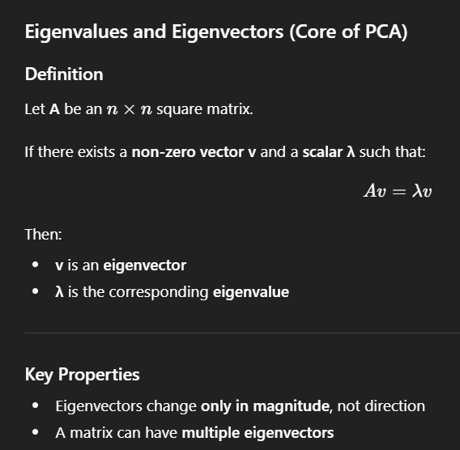
Eigenvalues and eigenvectors — the mathematical core of PCA (Av = λv)

Kernel PCA — non-linear
Uses a kernel function to implicitly map data into a higher-dimensional space where it becomes linearly separable, and applies PCA there — without ever explicitly computing the mapping (same kernel trick as SVM).

3.8 Missing Data & Imputation
Real datasets have gaps. How you fill (impute) them affects every model downstream. First, WHY is it missing?
- MCAR (Missing Completely At Random): the gap is unrelated to anything — safe to drop or impute simply.
- MAR (Missing At Random): missingness depends on OTHER observed features (e.g., income missing more often for a certain job) — impute using those features.
- MNAR (Missing Not At Random): missingness depends on the missing value itself (e.g., high earners hide income) — the hardest case; the fact that it is missing is itself information.

Common imputation strategies
- Drop: remove rows (if few) or a whole column (if mostly empty). Simple but throws away data.
- Mean / Median / Mode: fill numeric gaps with the mean (or median, which resists outliers); fill categorical gaps with the most frequent value. Fast, but shrinks variance and ignores relationships.
- Forward / backward fill: for time series, carry the last (or next) known value forward.
- KNN imputer: fill a gap using the average of the k most similar rows — respects feature relationships.
- Iterative / MICE: model each column with missing values as a function of the others, repeatedly — the most accurate but the most expensive.
- Missingness indicator: add a boolean column "was_missing" so the model can LEARN from the fact something was absent (crucial for MNAR).
✔ Correction: Fit the imputer on the TRAINING set only, then apply it to validation/test. Computing the mean (or KNN neighbours) over the full dataset before splitting leaks information — put imputation inside your pipeline/CV.

How to choose the right imputation method
Pick the filler by asking three questions: (a) how MUCH is missing, (b) WHY is it missing, and (c) what TYPE is the column.
- A lot of the column is missing (say >50–60%): often best to DROP the column — imputing most of it invents data.
- Only a few rows missing + plenty of data: dropping those rows is fine and simplest.
- Numeric column, roughly symmetric: fill with the MEAN.
- Numeric column with outliers / skew: fill with the MEDIAN (outliers drag the mean).
- Categorical column: fill with the MODE (most frequent category), or add a new category "Missing".
- Time series / ordered data: forward-fill or backward-fill (carry the last known value).
- Missing value depends on OTHER features (MAR): use KNN imputer (average of similar rows) or Iterative/MICE (model the column from the others) — more accurate but heavier.
- The FACT that it is missing is meaningful (MNAR): add a boolean "was_missing" flag column so the model can learn from the absence itself, then impute the value too.
Quick decision example
Age column, 3% missing, slightly skewed → median.
City column, 10% missing → mode, or a "Unknown" category.
Daily temperature with gaps → forward-fill.
Income missing mostly for one job type (MAR) → KNN / MICE + a missing-flag.
✔ Correction: Fit the imputer on the TRAINING data only (compute the mean/median/KNN neighbours there) and apply those same values to validation/test. Computing fill values over the whole dataset before splitting leaks information. Put imputation inside your pipeline so CV does it correctly.

3.9 Model Interpretability: SHAP, LIME & PDP
"Why did the model predict this?" is now a standard interview and stakeholder question (often called Explainable AI / XAI). Two levels: GLOBAL interpretability (how the model behaves overall) and LOCAL interpretability (why it made ONE specific prediction).
- Permutation importance (global): shuffle one feature and measure how much the score drops — a big drop means the feature mattered. Model-agnostic and simple (also covered in 3.6).
- SHAP (global + local): based on Shapley values from game theory. It fairly splits a single prediction among the features — each feature’s SHAP value is how much it pushed the prediction up or down from the average. Consistent and theoretically grounded; SHAP values also aggregate into a trustworthy global ranking. The most popular modern method.
- LIME (local only): explains ONE prediction by fitting a simple, interpretable model (like linear regression) on small perturbations around that point. Fast and intuitive, but explanations can be unstable — re-running may give slightly different answers.
- Partial Dependence Plot (PDP, global): shows the AVERAGE effect of one feature on the prediction as you sweep its value. The per-row version (ICE curves) reveals whether the effect differs across individuals.
Example
A loan model rejects an applicant. A SHAP force plot shows: base rate 0.30 approval; "debt-to-income = high" pushes it −0.22, "credit history = 8 yrs" pushes it +0.10 → final 0.18 → rejected. That is a LOCAL explanation the applicant can be told. A SHAP summary plot over all applicants gives the GLOBAL ranking of which features drive decisions.
Q: SHAP vs feature importance from the model — why prefer SHAP?
Built-in tree importance is biased toward high-cardinality features and only global. SHAP is consistent, works for any model, gives BOTH a global ranking and a per-prediction breakdown, and shows the DIRECTION of each feature’s effect (raised or lowered the prediction), not just its magnitude.

SHAP in detail (with examples)
SHAP explains a prediction by fairly SPLITTING it among the features — like splitting a restaurant bill among friends by how much each actually ordered. The idea comes from game theory (Shapley values): treat each feature as a "player" and ask how much it contributed to the final prediction, averaged over every possible order of adding features in.
Every prediction gets written as: prediction = base value (average prediction over all data) + sum of each feature’s SHAP value.
- Positive SHAP value → that feature pushed the prediction UP (toward the positive class / higher number).
- Negative SHAP value → it pushed the prediction DOWN.
- Size → how strong that push was for THIS specific row.
Local example — one loan application (why THIS person)
Base value (average approval score) = 0.30.
"debt-to-income = high" → SHAP −0.22 (pushes toward reject)
"credit history = 8 years" → SHAP +0.10 (pushes toward approve)
"loan amount = small" → SHAP +0.00
Final = 0.30 − 0.22 + 0.10 = 0.18 → rejected. The applicant can be told exactly which factors hurt.
Global example — the whole model
Average the ABSOLUTE SHAP values of each feature across all rows → a trustworthy ranking of which features matter most overall.
A SHAP summary plot also shows DIRECTION: e.g., high "debt-to-income" (red dots) consistently lowers approval, low (blue dots) raises it.
- Local interpretability: explains ONE prediction (the loan example above).
- Global interpretability: aggregate SHAP values across all rows to explain the whole model.
- Why people prefer SHAP: it is consistent and fair (built on solid theory), works for ANY model (tree, SVM, neural net), and gives BOTH the global ranking and the per-prediction breakdown WITH direction — unlike plain tree importance, which is global-only and biased toward high-cardinality features.
- Cost: computing exact SHAP is slow; in practice TreeSHAP (fast, for tree models) and KernelSHAP (model-agnostic, approximate) are used.
Q: SHAP vs LIME — what is the difference?
LIME fits a simple local model around one prediction and explains only that point; it is fast but can be unstable (re-running gives slightly different answers). SHAP gives consistent, theory-backed values, works locally AND globally, and shows the direction of each feature’s effect — but is more expensive to compute.

Tricky Interview Questions — Part 3
Q: Why does scaling matter for KNN but not for a decision tree?
KNN decides by distance: an unscaled feature with a big range (salary: 20,000–200,000) drowns out a small-range feature (age: 20–60), so neighbours are chosen by salary alone. A tree only asks threshold questions per feature ("age > 35?"); monotonic rescaling never changes which rows pass the threshold, so trees are scale-invariant.
Q: SMOTE before or after the train/test split?
Always AFTER the split, and only on the training set. If you SMOTE first, synthetic points generated from (future) test rows end up in training → leakage and inflated metrics.
Q: Why standardize before PCA?
PCA maximizes variance. Without standardization, a feature measured in big units (e.g., income in rupees) has artificially huge variance and hijacks the first principal component, regardless of its real importance.
Q: One-hot vs label encoding — when does label encoding silently hurt?
When applied to NOMINAL input features of linear or distance-based models: encoding Delhi=1, Mumbai=2, Pune=3 invents a fake order (Pune > Mumbai > Delhi) and fake distances. For tree models the damage is smaller (trees can split around it), and for the TARGET variable it is harmless because classes are just IDs.
Q: Both correlation filtering and PCA fight multicollinearity. What is the key difference?
Correlation filtering DROPS original features (keeps interpretability). PCA REPLACES them with combined components — multicollinearity disappears because components are orthogonal, but each component is a mix of all features and is harder to explain to stakeholders.

Part 4 — Supervised Learning: Linear Regression & Regularization

4.1 Linear Regression
Linear regression models the relationship between variables using a straight line with a constant slope. It determines the relationship between one dependent variable (Y) and one or more independent variables (X).
- OLS (Ordinary Least Squares): the core method used to estimate the coefficients — it finds the line that minimizes the sum of squared residuals.
- Loss function: Mean Squared Error. MSE = (1/n) × Σ(actual − predicted)².

Why divide by 2 in the cost function (but not in the metric)?
We don’t divide by 2 in the MSE metric, but we often do in the optimization cost function: when you take the derivative for gradient descent, the power 2 comes down and cancels with the 1/2 multiplier — the derivative becomes cleaner. It changes nothing about WHERE the minimum is.

How OLS finds the coefficients
OLS = Ordinary Least Squares. It picks the line (the coefficients) that makes the total SQUARED error between predictions and actual values as small as possible. "Least squares" = smallest sum of squared residuals.
For a line y = m·x + b, the residual of each point is (actual − predicted). OLS minimizes:
Cost = Σ (y_i − (m·x_i + b))² (sum over all points)
Why SQUARE the errors? So positive and negative errors do not cancel, and so big mistakes are punished more. Squaring also makes the cost a smooth bowl with ONE lowest point, which we can solve exactly.

Two ways OLS solves it
- 1. Calculus (closed form): take the derivative of the cost with respect to m and b, set both to 0, and solve. For simple regression this gives neat formulas:
m = Σ (x_i − x̄)(y_i − ȳ) / Σ (x_i − x̄)² (slope)
b = ȳ − m·x̄ (intercept)
- 2. Normal Equation (matrix form, many features): the same idea for all coefficients at once:
β = (Xᵀ X)⁻¹ Xᵀ y
This finds the exact best coefficients in one shot — no iteration. (For very large datasets we switch to gradient descent instead, because inverting XᵀX gets expensive.)
Tiny worked example
Points: (1,2), (2,3), (3,5). Means: x̄ = 2, ȳ = 3.33.
Slope m = [(1−2)(2−3.33) + (2−2)(3−3.33) + (3−2)(5−3.33)] / [(1−2)²+(2−2)²+(3−2)²]
= [(−1)(−1.33) + 0 + (1)(1.67)] / [1+0+1] = (1.33+1.67)/2 = 1.5.
Intercept b = 3.33 − 1.5×2 = 0.33. So best line: y = 1.5x + 0.33.
＋ Added concept: OLS gives the coefficients that make the squared error smallest. Closed-form (normal equation) when features are few; gradient descent when data/features are large — both chase the same minimum.

4.2 Assumptions of Linear Regression
＋ Added concept: Your notes listed 3 assumptions. Interviewers usually expect 5 — Linearity and Independence of errors were missing and are added below.
- 1. Linearity (added): the relationship between X and Y is actually linear. Check with scatter/residual plots.
- 2. Normality of residuals: a residual is how far a point sits vertically from the regression line (+ or −). Normality means residuals are symmetric: most errors are near zero and large errors are rare.
- 3. Homoscedasticity: residuals have CONSTANT variance — the size of the errors does not grow or shrink as the predicted value changes. The model’s errors are stable across all levels of prediction.
- 4. No / little multicollinearity: independent variables should not be highly correlated with each other — correlated features explain the same information and make coefficients unstable.
- 5. Independence of errors (added): residuals should not be correlated with each other (no autocorrelation) — especially relevant for time-series data.
＋ Added concept: How to DETECT multicollinearity (often asked): correlation matrix for pairwise checks, and VIF (Variance Inflation Factor) for multi-feature checks — VIF > 5 (some use 10) signals a problem.

4.3 R² and Adjusted R²
- RSS (Residual Sum of Squares): Σ(actual − predicted)². Depends on the scale of the target; lower = better predictions.
- TSS (Total Sum of Squares): Σ(observed − mean of Y)² — total variation in the data.
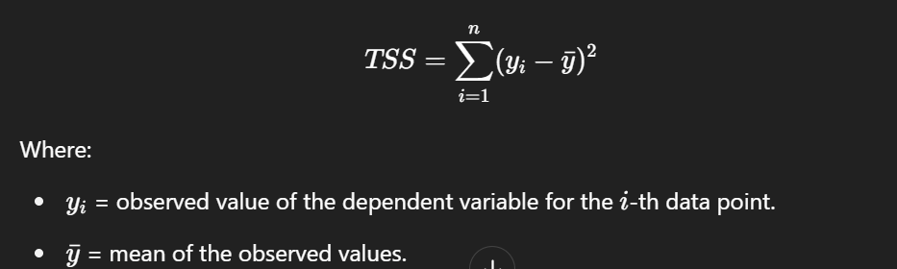
TSS — total variation of the observed values around their mean
R² (coefficient of determination) = (TSS − RSS) / TSS = Explained variation / Total variation. It answers: what percentage of the change in Y is explained by the X variables? R² = 1 is a perfect fit. There is no universal cut-off below which regression is "bad" — it depends on the domain.
✔ Correction: The note said "R² always lies between 0 and 1." That holds for the TRAINING data of a model with an intercept. On TEST data (or without intercept), R² can be NEGATIVE — it means the model predicts worse than simply always predicting the mean. A classic interview follow-up.

Problem with R² → Adjusted R²
- R² NEVER decreases when you add variables — even useless ones. It stays the same or increases, so it can’t tell you if a new feature genuinely helps.
- Adjusted R² accounts for the NUMBER of predictors: it punishes the model for extra useless features. Add a junk feature → adjusted R² goes DOWN. Range: −∞ to 1 (1 is best).
Example
Model with 5 real features: R² = 0.80, Adj-R² = 0.78. Add a column of random noise: R² = 0.801 (up!), Adj-R² = 0.77 (down — correctly signalling the new feature is useless).

4.4 Regularization: Ridge (L2) and Lasso (L1)
Regularization improves the model and prevents OVERFITTING by adding a penalty on coefficient size to the cost function. Ridge and Lasso are the simplest ways to reduce model complexity in linear regression. λ (lambda) is the shrinkage parameter controlling penalty strength; β₁...βp are the coefficients.

Ridge Regression — L2 (solves overfitting)
Cost = RSS + λ × Σ(βⱼ²) — penalty is the SQUARE of coefficient magnitudes. Shrinks coefficients toward zero (but never exactly zero) → reduces model complexity and helps with multicollinearity.
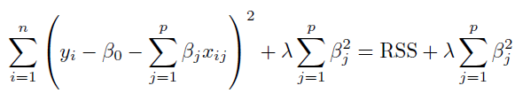
Ridge cost function: RSS + λ Σ βj²

Lasso Regression — L1 (feature selection)
Cost = RSS + λ × Σ|βⱼ| — penalty is the ABSOLUTE magnitude. L1 can push coefficients to EXACTLY zero, so features contributing little to Y are completely dropped → Lasso reduces overfitting AND performs feature selection.
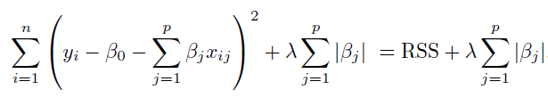
Lasso cost function: RSS + λ Σ |βj|
- Both Ridge and Lasso can absolutely be used with polynomial features.
Intuition example
10 features but only 3 truly matter. Ridge: all 10 coefficients become small (e.g., the useless ones ≈ 0.02) but stay in the model. Lasso: the 7 useless coefficients become exactly 0 — the model itself tells you which 3 features matter.

Elastic Net — L1 + L2 combined
Elastic Net blends BOTH penalties: it adds Lasso’s absolute-value term (L1) and Ridge’s squared term (L2) to the cost. A mixing hyperparameter (l1_ratio, often called α or ρ) decides how much of each: l1_ratio = 1 is pure Lasso, 0 is pure Ridge.
- Why it exists: pure Lasso struggles when features are highly CORRELATED — it tends to arbitrarily keep one and zero the rest, and it can select at most n features when p > n. Ridge keeps all correlated features but never zeros any.
- Best of both: the L1 part still performs feature selection (drives some coefficients to zero), while the L2 part handles correlated groups gracefully (the "grouping effect" — correlated features get similar coefficients and tend to enter or leave together).
- Use when: you have many features, some correlated, and you want automatic selection AND stability. It is often the safest default among the three regularizers.
Example
Genomics data with 10,000 correlated gene features and 200 samples (p ≫ n). Lasso alone picks an unstable handful; Ridge keeps all 10,000. Elastic Net (l1_ratio ≈ 0.5) selects a stable SET of related genes together — selection plus grouping.

Tricky Interview Questions — Part 4
Q: Why does Lasso produce exactly-zero coefficients but Ridge doesn’t?
Geometric answer: the L1 constraint region is a diamond with sharp corners on the axes; the optimal solution often lands ON a corner, where some coefficients are exactly 0. The L2 region is a circle — smooth, no corners — so coefficients shrink but almost never hit exactly 0. Calculus answer: the L1 penalty’s gradient is constant (±λ) near zero, strong enough to push small coefficients all the way to 0; the L2 gradient (2λβ) fades as β→0.
Q: R² on the test set came out negative. Is the code broken?
No. Negative test-R² simply means the model is WORSE than predicting the mean of y for every row — a sign of severe overfitting or a meaningless model. R² is only guaranteed in [0,1] on training data with an intercept.
Q: When would you prefer Ridge over Lasso?
When most features genuinely contribute and/or features are highly correlated. With correlated features Lasso tends to arbitrarily pick one and zero out the rest, which is unstable; Ridge shares the weight among them. (Elastic Net combines both penalties to get the best of each.)
Q: Adding a feature increased R² — does that prove the feature is useful?
No. R² mathematically cannot decrease when features are added, even random noise. Check Adjusted R² (or cross-validated error): if it falls, the feature is hurting.

Part 5 — Classification Algorithms

5.1 Logistic Regression
Logistic Regression is a CLASSIFICATION algorithm, despite having "regression" in its name.
- Target: must be categorical.
- Features: assumes LOW multicollinearity — highly correlated features make the coefficients unstable to interpret, but do not "break" the model.
- How are β₀, β₁... estimated? NOT by OLS. Logistic regression uses Maximum Likelihood Estimation (MLE) — it finds the coefficients that make the observed labels most probable.
- Loss function: Log Loss / Binary Cross-Entropy.
- Regularization: L1 (Lasso) and L2 (Ridge) both available.
- Evaluation: confusion matrix (and the metrics built on it) — see Part 8.
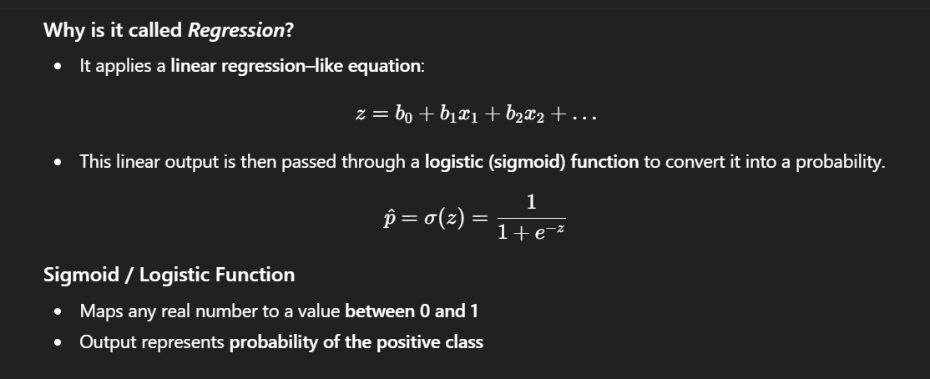
Why "regression"? A linear equation z = b0 + b1x1 + ... is passed through the sigmoid to become a probability between 0 and 1
Example
z = −2 + 0.05×(study hours). Student studies 60 hours → z = 1 → sigmoid(1) ≈ 0.73 → predicted probability of passing = 73% → class "Pass" (threshold 0.5).

Sigmoid, logit and log-odds explained
Logistic regression predicts a PROBABILITY (0 to 1). But a linear equation (w·x + b) can output any number, from −∞ to +∞. These three terms are the bridge between "any number" and "a probability".
- Odds: probability of YES divided by probability of NO. If p = 0.8, odds = 0.8/0.2 = 4 (4-to-1 in favour). Odds range from 0 to +∞.
- Log-odds (= logit): the natural log of the odds, ln(p / (1−p)). This stretches odds to the full −∞…+∞ range, so a linear equation can produce it. logit(p) = ln(p/(1−p)).
- Sigmoid: the REVERSE of the logit. It takes any number (−∞…+∞) and squashes it back into a probability (0–1). Formula: σ(z) = 1 / (1 + e⁻ᶻ).
So logit turns probability → a straight-line scale; sigmoid turns the straight-line output → back into probability. They are inverses of each other.

How they fit together in logistic regression
Step 1: z = w·x + b (linear part → this z is the LOG-ODDS / logit)
Step 2: p = sigmoid(z) = 1 / (1 + e^-z) → a probability 0..1
Step 3: predict class 1 if p ≥ 0.5, else class 0
Example with numbers
Suppose the model computes z = w·x + b = 2.0 for an email.
z = 2.0 is the LOG-ODDS. Odds = e².⁰ ≈ 7.39 (about 7-to-1 it is spam).
Probability p = sigmoid(2.0) = 1/(1+e⁻²) ≈ 0.88 → 88% spam → predict SPAM.
If instead z = 0 → odds = 1 (50/50) → sigmoid(0) = 0.5 → right on the boundary.
If z = −2 → p ≈ 0.12 → predict NOT spam.
＋ Added concept: Why logistic regression uses log-odds: a coefficient w means "for a one-unit increase in that feature, the LOG-ODDS change by w" (so the odds multiply by eʷ). This keeps the model linear in log-odds while the output stays a valid probability thanks to the sigmoid.

5.2 K-Nearest Neighbours (KNN)
- Supervised; works for both classification and regression.
- Non-parametric and instance-based (lazy): NO training phase — all computation happens at prediction time.
- KNN does not learn any formula. With k = 3 it "simply checks the 3 nearest neighbours and answers based on them."

How it works
- 1. Choose K (number of neighbours). 2. Select a distance metric. 3. Compute distance from the test point to ALL training points. 4. Take the K nearest. 5. Predict: classification → majority vote; regression → average (or weighted average).
- There is no fixed rule for the best K (try several with cross-validation). Performance degrades in high dimensions (curse of dimensionality). Feature scaling is essential.
Example
New fruit: weight 160 g, redness 0.8. Its 3 nearest neighbours in the data are Apple, Apple, Cherry → predict Apple (2 votes vs 1).

KNN: what happens on a tie?
A tie can happen two ways in KNN — and it helps to know the defaults (scikit-learn behaviour):
- Tie in the VOTE (e.g., k = 4 gives 2 class-A and 2 class-B): scikit-learn does not do a random coin-flip. It picks the class with the SMALLEST label value — i.e., whichever class comes FIRST in sorted/label order (class 0 before class 1, "A" before "B"). It is deterministic, not random.
- Tie in DISTANCE (the k-th and (k+1)-th neighbours are equally far): the neighbours are taken in the order the algorithm encountered them, so which one is included can depend on data ordering.
- How to avoid ties: use an ODD k for binary classification (k = 3, 5, 7…) so a 50/50 vote cannot occur, or use weights="distance" so closer neighbours count more and an exact tie is unlikely.
Example
k = 4, neighbours = [A, A, B, B]. Default (uniform weights) → tie → scikit-learn predicts A (the lower class label), not a random pick.
Switch to weights="distance": if the two A’s are closer than the two B’s, A wins by weight — the tie is broken sensibly.
Simplest fix: use k = 5 so one class always has the majority.

5.3 Naive Bayes
A classification technique based on Bayes’ Theorem with the "naive" assumption that all features predicting the target are INDEPENDENT of each other. In real data features usually do depend on each other — Naive Bayes simply ignores this, and still works surprisingly well.
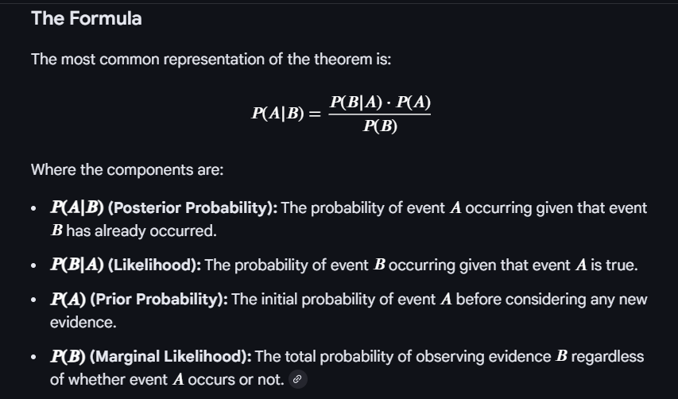
Bayes’ Theorem: posterior, likelihood, prior and marginal likelihood
Because of the conditional-independence assumption, the joint likelihood becomes a simple product of per-feature probabilities:

Naive independence: P(X|y) = P(x1|y) × P(x2|y) × ... × P(xn|y)
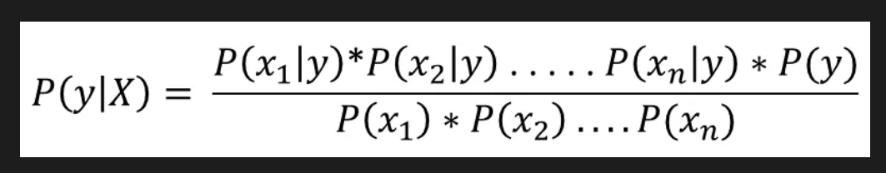
Putting it together: the posterior P(y|X) used for classification

Laplace (add-one) smoothing
Problem: probabilities are estimated from training frequencies. If a word never appeared with a class, its probability is 0 — and since everything is multiplied, ONE unseen word makes the whole product 0 and completely rejects the class.
Fix: add a small constant (usually 1) to every count in the numerator, and add the number of possible feature values (e.g., vocabulary size V) to the denominator → no probability is ever exactly zero.
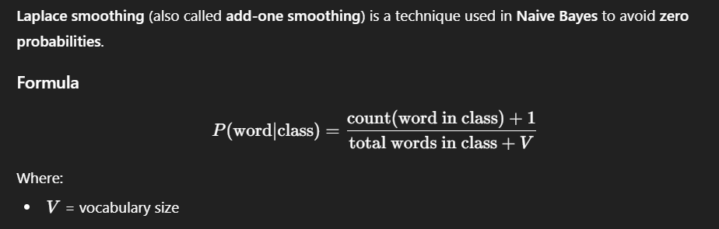
Laplace smoothing formula: (count + 1) / (total words in class + V)
Example
Spam classifier. Word "blockchain" never appeared in any ham email → P(blockchain|ham) = 0 → any email containing it could NEVER be ham. With smoothing: (0+1)/(10,000+50,000) — tiny, but not zero, so other words still get a say.

5.4 Support Vector Machines (SVM)
Supervised algorithm for classification and regression. Core idea: find the OPTIMAL hyperplane that best separates the classes in the labelled training data.
- Hyperplane: the decision boundary separating classes.
- Support vectors: the data points closest to the hyperplane — they alone define its position and orientation.
- Margin: the shortest distance between the hyperplane and the nearest support vectors. SVM maximizes this margin.

Linearly separable or not — the Kernel Trick
If a straight line/plane can separate the data, it is linearly separable. If not, we can project the data into a HIGHER-dimensional space where it may become separable. A kernel is a mathematical function that lets a linear classifier solve a non-linear problem by IMPLICITLY mapping data to that higher dimension — the points are never actually transformed. This computational shortcut is the "Kernel Trick". There is no universal rule for which kernel is best.
- Linear kernel: for linearly separable data; computationally efficient for large datasets.
- Polynomial kernel: uses polynomial combinations of features; higher degree → more complex boundaries.
- RBF (Radial Basis Function) kernel: measures SIMILARITY between two points: value 1 when X₁ = X₂, approaching 0 as distance grows. Gaussian in shape, controlled by the gamma parameter; behaviour resembles KNN. The most commonly used kernel in practice.
Example
Points on a 1-D line: class A at −2 and 2, class B at 0. No single threshold separates them. Map x → (x, x²): A becomes (−2,4),(2,4); B becomes (0,0). In 2-D a horizontal line at x² = 2 separates them perfectly — that is what a kernel does implicitly.

Hard margin vs Soft margin
- Hard margin: used when data is PERFECTLY linearly separable — zero tolerance for misclassification. Works only with no noise / no overlap.
- Soft margin: allows SOME controlled misclassification → more flexible and more robust to outliers and noise. The key difference is the tolerance for misclassification.

The C parameter (regularization)
- Small C: allows more misclassifications → wider margin, simpler model, less likely to overfit.
- Large C: punishes misclassifications heavily → narrow margin, can overfit.
- The penalty for a point grows the farther it lies on the WRONG side of the boundary.

5.5 Decision Trees
Supervised; works for both categorical and continuous targets. The primary goal: find the best splits that divide the data into the purest possible groups. Picking a random root will not solve the problem — the split must be chosen by a purity measure: Gini impurity, Information Gain (entropy) or Chi-square.
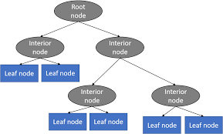
Structure of a decision tree: root, interior and leaf nodes
- Root node: the first node at the top.
- Leaf / terminal nodes: nodes where no further splitting happens.
- Pruning: cutting down nodes to stop overfitting.
What makes a split "good"?
Bad split — Left: 6 Pass / 5 Fail, Right: 5 Pass / 6 Fail → still mixed → useless.
Good split — Left: 10 Pass / 1 Fail, Right: 1 Pass / 10 Fail → very pure → informative.

Entropy
Entropy measures impurity. Entropy = 0 → the node is completely pure (one class only). For a BINARY target the maximum is 1, reached when the node is split 50–50.
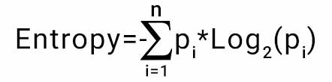
Entropy formula
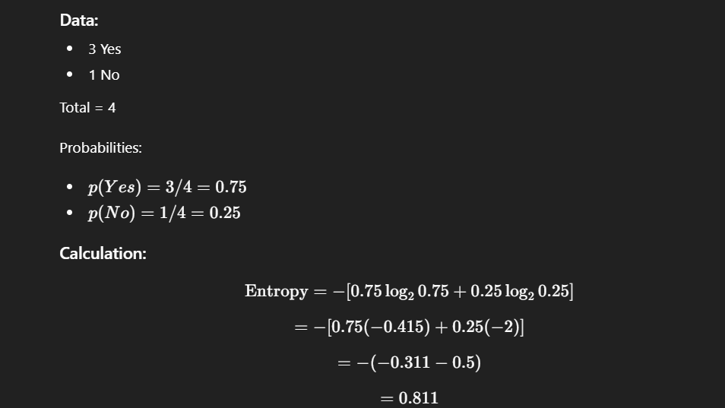
Worked entropy example: 3 Yes / 1 No → entropy = 0.811
✔ Correction: "Entropy ranges between 0 and 1" is only true for BINARY classification. With k classes the maximum is log₂(k) — e.g., 3 equally likely classes give entropy ≈ 1.585. Gini’s "0 to 0.5" range is likewise binary-only (general max = 1 − 1/k).

Gini impurity
Same purpose as entropy — measuring split purity. A pure node has Gini = 0; for binary targets the maximum is 0.5. Gini is usually preferred because it is easier/faster to compute (no logarithm). Note: these impurity measures apply to classification; for continuous targets, regression trees use variance/MSE reduction instead.
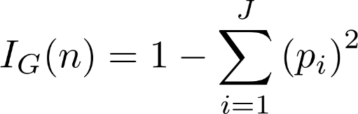
Gini impurity formula

Information Gain
IG = Entropy(parent) − weighted Entropy(children). The more the entropy drops after a split, the more information was gained. The feature with the HIGHEST information gain is selected for the split. Information gain cannot exist without a split.

Hyperparameters
- max_depth — maximum depth of the tree.
- min_samples_split — minimum samples required to split an internal node.
- min_samples_leaf — minimum samples required at a leaf node.
- max_features — number of features considered when looking for the best split.

Pre-pruning vs Post-pruning
- Pre-pruning: restrict the tree BEFORE/WHILE building it (max_depth, min_samples_split) to prevent overfitting.
- Post-pruning (backward pruning): grow the full (deep, overfitted) tree first, then cut branches back — in sklearn via cost-complexity pruning (ccp_alpha).
- Main weakness of a single tree: a small change in training data can produce a completely different tree (high variance) — the motivation for Random Forest.

5.6 Random Forest
Supervised algorithm for classification and regression. A Random Forest is a collection of decision trees trained in a special way: a single decision tree builds ONE tree using ALL data and ALL features; a random forest builds MANY trees, each using random data and random features. Two sources of randomness:
- (1) Bootstrapping (data randomness): each tree trains on a bootstrap sample — random sampling WITH replacement, same size as the original dataset. Some rows appear multiple times, some not at all.
- (2) Feature randomness (split randomness): at each split the tree considers only a RANDOM SUBSET of features, not all of them — this de-correlates the trees.

Bootstrapping & Bagging
- Bootstrapping: a resampling technique — create multiple new datasets from the original by sampling with replacement.
- Bootstrap Aggregation = Bagging: train multiple models on bootstrap samples and combine (average/vote) their predictions — used to estimate performance and to reduce overfitting.

Parameters
- n_estimators — number of trees built before averaging predictions.
- max_features — max features considered when splitting a node.
- min_samples_leaf — minimum samples at a leaf.
- oob_score — "out-of-bag" evaluation: roughly one-third of rows are NOT in a given tree’s bootstrap sample; those out-of-bag rows act as a built-in validation set, giving cross-validation-like evaluation for free.

Tricky Interview Questions — Part 5
Q: Why does logistic regression use MLE instead of OLS?
Squared error on sigmoid outputs gives a NON-convex cost with many local minima, and OLS’s assumptions (normal, constant-variance errors) don’t hold for 0/1 outcomes. Maximizing likelihood (equivalently minimizing log loss) gives a convex problem with one global minimum that gradient descent reliably finds.
Q: Naive Bayes’ independence assumption is almost always false. Why does it still work?
For classification we only need the CORRECT CLASS to get the highest score — the probability values themselves can be badly miscalibrated. The ranking of classes often survives violated independence, especially in high-dimensional sparse data like text.
Q: Why does Random Forest need feature randomness when bagging already randomizes the data?
With bootstrapping alone, every tree would still grab the same few dominant features at the top, making the trees highly CORRELATED — and averaging correlated trees barely reduces variance. Random feature subsets force trees to be different, and averaging de-correlated trees is what actually cuts variance.
Q: Gini vs Entropy — does the choice matter?
In practice they produce very similar trees. Gini is preferred mainly because it avoids computing logarithms (faster). Entropy slightly favours more balanced splits. It is rarely the reason a model performs differently.
Q: In KNN, what happens if K is too small or too large?
K too small (e.g., 1): the prediction follows individual noisy points → overfitting (high variance). K too large: neighbourhoods include points of other classes and everything drifts toward the majority class → underfitting (high bias). K is a bias–variance dial; tune it with cross-validation and prefer odd K for binary problems to avoid ties.
Q: What do the support vectors actually do? What if we delete other points?
Only the support vectors (the points touching/violating the margin) define the hyperplane. Deleting any NON-support-vector point changes nothing — retraining gives the same boundary. That is why SVMs can be memory-efficient at prediction time.

Part 6 — Ensemble Methods
Ensemble methods create multiple models and combine them to produce improved results — usually more accurate than any single model. Used for both regression and classification.
Type | How models learn | Mainly reduces | Example
Bagging | In PARALLEL on bootstrap samples | Variance (overfitting) | Random Forest
Boosting | SEQUENTIALLY, each fixing previous errors | Bias (underfitting) | AdaBoost, GBM, XGBoost
Stacking | Heterogeneous models + meta-learner | Both (via combination) | KNN + LogReg + SVM → meta-model

6.1 Bagging (Bootstrap Aggregation)
Train many models on different bootstrap samples (random sampling with replacement) and combine their predictions (vote/average). It reduces overfitting. Random Forest is the classic example. Bagging is not limited to trees — e.g., bagging many KNN models on different data subsets smooths the decision boundary and makes it more robust to noise without increasing k.

6.2 Boosting
Models are built one after another; each new model tries to correct the errors of the previous ones. Models keep being added until the training data is predicted well enough or the maximum number of models is reached.

AdaBoost (Adaptive Boosting)
- Creates many WEAK learners — usually decision stumps (trees with a single split, depth = 1). The number of stumps is user-defined.
- Initially all observations get EQUAL weights. A stump is trained; it automatically picks the feature + threshold that minimizes the weighted error.
- Weight update: misclassified observations → weight INCREASED; correctly classified → weight DECREASED; then all weights are normalized to sum to 1.
- Because hard observations now weigh more, the NEXT stump focuses on them. Repeat sequentially until the chosen number of stumps is built or error ≥ 0.5.
- Each stump picks one feature and one threshold; across rounds, different features can be selected, and a feature can be reused.
Example
Round 1 stump misclassifies 10 fraud cases → their weights rise. Round 2 stump is now "paid more" to get exactly those 10 right, so it picks a split that handles them — the ensemble gradually covers the hard cases.

Gradient Boosting
- Learning happens by optimizing a LOSS function. Builds larger trees than AdaBoost (typically depth 3–8, not stumps).
- Mechanism: compute residual errors (actual − predicted); train the next tree to predict those residuals; scale the new tree’s output by a learning rate; add it to the ensemble. Repeat until a stopping criterion (fixed number of trees, or minimal loss improvement).
- Each new tree faces smaller and smaller residuals, so the total prediction converges toward the actual values.
Worked example
Actual house price = 100. Initial guess (mean) = 70 → residual 30.
Tree 1 predicts the residual ≈ 30; with learning rate 0.1 → prediction = 70 + 0.1×30 = 73 → new residual 27.
Tree 2 learns 27 → prediction = 73 + 2.7 = 75.7 ... hundreds of small corrections later, prediction ≈ 100.
Final prediction = initial guess + LR×Tree1 + LR×Tree2 + ... + LR×TreeN.

XGBoost
An optimized, regularized, engineered version of Gradient Boosting built for speed, accuracy and scalability. Key differences from plain GBM:
- Uses first-order AND second-order derivatives (gradient + Hessian); plain GBM uses only first-order residuals.
- Built-in regularization; post-pruning (bottom-up), whereas pruning in plain GBM is minimal/absent.
- Handles missing values automatically; supports custom loss functions and early stopping.
- Parallelism — common confusion: XGBoost does NOT build multiple trees in parallel (boosting is inherently sequential). The parallel computation happens INSIDE a single tree — evaluating candidate splits across features simultaneously.

6.3 Stacking
Stacking combines HETEROGENEOUS models (different algorithms — e.g., KNN, Logistic Regression, SVM). Each base model trains on the same dataset but learns patterns in its own way. Their output predictions are then used as INPUT FEATURES for another model — the meta-model (meta-learner) — which learns how to optimally combine them into the final output.
- So stacking has at least TWO levels. More levels are possible but do not guarantee better performance.
- Leakage guard: the meta-model is trained on OUT-OF-FOLD predictions of the base models (each base model predicts rows it was not trained on), otherwise the meta-model would learn from memorized answers.
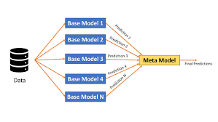
Stacking: base models’ predictions become the meta-model’s input features

Tricky Interview Questions — Part 6
Q: Why does bagging reduce variance while boosting reduces bias?
Bagging averages many INDEPENDENT-ish overfitted models — random errors cancel out, so the ensemble is more stable (variance ↓). Boosting chains many WEAK (high-bias) models, each correcting what the previous ones missed, steadily increasing the ensemble’s expressive power (bias ↓). That is also why boosting CAN overfit if you add too many rounds, while bagging rarely does.
Q: "XGBoost is fast because it builds trees in parallel" — true or false?
False, and a very common trap. Boosting is sequential by definition (tree N needs the errors left by trees 1...N−1). XGBoost’s parallelism is WITHIN each tree: candidate splits over features/bins are evaluated in parallel.
Q: Why use a small learning rate plus many trees in gradient boosting?
Each tree then makes only a tiny correction, so no single tree can overfit the residual noise; many small steps generalize better than few big ones. Trade-off: more trees = more training time. Learning rate and n_estimators are tuned together.
Q: In stacking, why out-of-fold predictions for the meta-model?
If a base model predicts the same rows it trained on, those predictions are unrealistically accurate (memorized). The meta-model would learn to over-trust that base model and fail on new data. Out-of-fold predictions reflect honest, generalization-level performance.

Part 7 — Gradient Descent & Loss Functions

7.1 Gradient Descent
Gradient Descent is an optimization algorithm used to MINIMIZE a cost (loss) function. In simple words: we stand on the slope of the cost surface and keep stepping downhill until we reach the lowest point (the global minimum). A convex function has exactly one global minimum and no local minima — which is why convex losses are loved.
- Slope pointing to the right is positive (and vice versa). The NEGATIVE gradient always points downhill fastest, so we move opposite to the slope.
- The slope is computed using partial derivatives of the cost with respect to each parameter (m = weight/slope of the hypothesis, b = bias/intercept).
- Update rule: new parameter = old parameter − (learning rate × gradient).
- Learning rate α: too LARGE → may overshoot and bounce past the minimum; too SMALL → painfully slow convergence.
- Near a minimum the derivative becomes smaller, so the steps automatically become smaller too — the algorithm naturally slows down as it closes in.
- Stop when the gradient is close to zero or after a fixed number of iterations.
For a simple linear model with two parameters (w and b), the cost surface looks like a bowl. Gradient descent rolls down this bowl to the bottom.
Example
Cost = (w − 5)². Start w = 1, α = 0.1. Gradient = 2(w−5) = −8 → w = 1 − 0.1×(−8) = 1.8 → next gradient −6.4 → w = 2.44 ... each step moves toward w = 5, in shrinking steps as the slope flattens.

Why feature scaling speeds up gradient descent
Scaling the inputs (mean normalization or z-score) gives the error surface a more SPHERICAL (circular) shape. Without scaling it is a long, narrow, high-curvature ellipse, and the gradient zig-zags across the valley taking many steps that are not in the optimal direction.
- When the surface is circular, the gradient points straight at the minimum → learning is fast and direct.
- When the surface is a stretched ellipse, each step overshoots sideways → many wasted, oscillating steps.
＋ Added concept: This is the same reason distance-based and gradient-based models need scaling (see 3.3): the optimizer literally takes a more efficient path on a well-scaled surface.

Variants by how much data each step uses
- Batch GD: uses the WHOLE dataset for every update — accurate gradient, but slow and memory-heavy.
- Stochastic GD (SGD): uses ONE randomly picked sample per update. Fast and noisy.
- Mini-batch GD: uses a small random batch per update — the practical middle ground (e.g., 32, 64, 128 samples).

Local minima & saddle points — and how to escape
A local minimum is the lowest point in a small neighbourhood but not overall; a saddle point has zero gradient yet is neither a minimum nor a maximum. Getting stuck in either means sub-optimal performance.
- Randomness (from SGD/mini-batch): the loss landscape for the next randomly sampled point is slightly different, so even if we are stuck for one sample, the jolting movement of the next sample shakes us out and lets us keep moving toward a better minimum.
A subtlety worth knowing: in high-dimensional models (deep networks especially), true local minima are actually RARE. The more common trap is the SADDLE POINT — a spot that curves up in some directions and down in others, where the gradient is nearly zero so plain gradient descent crawls almost to a halt. The escape tricks below help with both.
- 1. Stochastic / mini-batch noise: each batch gives a slightly different gradient. That jitter nudges the parameters off a flat saddle or out of a shallow basin — the same noise that makes SGD "messy" is what frees it.
- 2. Momentum: accumulated velocity carries the parameters THROUGH flat regions and OVER small bumps, like a ball with enough speed rolling out of a shallow dip into a deeper valley.
- 3. Learning-rate schedules & warm restarts: periodically RAISING the learning rate again (cyclical LR / SGDR) gives a deliberate "kick" that can pop the model out of a basin so it can search for a better one, then anneal back down.
- 4. Adaptive optimizers (Adam, RMSProp): by giving each parameter its own step size, they keep moving along the flat directions of a saddle where a single global learning rate would stall.
- 5. Good initialization & normalization: sensible weight initialization and batch/layer normalization smooth the loss surface so there are fewer nasty traps to begin with.
A concrete 1-D example shows momentum beating plain gradient descent:
Worked example — a tilted double-well
Function: f(w) = w⁴ − 3w² + 0.5w. It has TWO valleys: a deeper one (global minimum) near w ≈ −1.30 with f ≈ −2.86, and a shallower one (local minimum) near w ≈ +1.22 with f ≈ −1.64, separated by a small hump near w ≈ 0.
Plain gradient descent, start at w = +1.5: the gradient points left, so w slides down into the NEAREST valley (the shallow one) and settles at w ≈ 1.22. The gradient there is 0, so it STOPS — stuck in the local minimum at −1.64, never seeing the better valley.
With momentum, same start: as w rolls left it builds up velocity. When it reaches the shallow valley it does not stop — the accumulated speed carries it UP and OVER the central hump, down into the deeper valley, settling near w ≈ −1.30 (the global minimum at −2.86).
With SGD noise: random per-batch kicks can likewise bump w over the hump, especially early in training when the noise is large relative to the small barrier.
＋ Added concept: The common thread: plain gradient descent only ever moves DOWNHILL on the current point’s slope, so a zero gradient = full stop. Noise and momentum both add a source of movement that does NOT depend on the local slope, which is exactly what is needed to leave a flat or shallow trap.

Optimizers — making gradient descent smarter
The plain update rule can be slow or get stuck. These optimizers improve it, each building on the previous one.
1. SGD with Momentum.
Momentum gives the algorithm "memory" of its past direction using an Exponential Moving Average (EMA) — a moving average that weights recent gradients more heavily. Intuition: if I keep being told to move in the same direction, I gain confidence and take bigger steps that way. The current update depends on the present gradient PLUS the accumulated past gradients (scaled by a factor, often called gamma or alpha).
- Trade-off: moving fast is not always good. Momentum can OVERSHOOT and oscillate in and out of the minimum valley (taking several U-turns) before settling. Despite the U-turns, it still converges FASTER than vanilla gradient descent.
2. Nesterov Accelerated Gradient (NAG).
A smarter momentum: first compute a "look-ahead" position using the existing velocity, then measure the gradient THERE, and use that to make the real update. Because it looks ahead before stepping, it still overshoots but by a SMALLER amount — shorter U-turns and less oscillation than plain momentum.
3. Adagrad (Adaptive Gradient).
Uses a DIFFERENT learning rate for each parameter, automatically — no manual tuning of the rate. It divides the learning rate by the square root of the sum of all past squared gradients for that parameter.
- Downside: the denominator (sum of squared gradients) only ever GROWS, so the learning rate keeps shrinking monotonically and can become so tiny that the model stops learning altogether.
4. RMSProp (Root Mean Square Propagation).
Fixes Adagrad’s vanishing learning rate. Instead of summing ALL past squared gradients, it keeps a MOVING AVERAGE of recent squared gradients, so old gradients fade away and the learning rate does not collapse to zero.
- Note: the learning rate still has to be set manually, and the suggested default does not work for every problem.
5. Adam (Adaptive Moment Estimation).
The most popular optimizer. It combines the ideas of Momentum (a moving average of past gradients — the "first moment") and RMSProp (a moving average of past squared gradients — the "second moment"), and adds a bias-correction step so the early estimates are not skewed toward zero.
How to remember the family
Momentum = remember the DIRECTION you were going.
RMSProp = remember how BIG recent gradients were, per parameter.
Adam = remember BOTH (direction + size) → fast, robust default.

A fuller comparison of the common optimizers — what each adds, what to watch for, and when to use it — is given below.

Optimizers in detail — the update rules
Every optimizer is a tweak to the one-line update w ← w − α·g (g = gradient, α = learning rate). Each one changes either the DIRECTION it steps (by mixing in past gradients) or the STEP SIZE per parameter (by tracking how big past gradients were). The engine behind most of them is the Exponential Moving Average (EMA).

The Exponential Moving Average (EMA), with numbers
An EMA blends the new value with the running average: avg ← β·avg + (1−β)·new. A larger β means a longer memory (smoother, slower to react); a smaller β reacts faster. With β = 0.9 the average roughly remembers the last ~10 values.
EMA example (β = 0.9)
Start avg = 0. New gradients arrive: 1, 1, 1, ...
After 1st: 0.9×0 + 0.1×1 = 0.10
After 2nd: 0.9×0.10 + 0.1×1 = 0.19
After 3rd: 0.9×0.19 + 0.1×1 = 0.271 … climbing smoothly toward 1.
This smoothing is why momentum keeps a steady direction instead of jittering with every noisy gradient.

Each optimizer’s rule
Update rules (pseudo-code)
SGD: w = w - lr * g

Momentum: v = beta*v + (1-beta)*g # EMA of gradients (direction)
w = w - lr * v

Nesterov: look = w - lr*beta*v # peek ahead first
g_look = grad(look) # gradient at the look-ahead point
v = beta*v + (1-beta)*g_look
w = w - lr * v

Adagrad: s = s + g*g # SUM of squared grads (never decays)
w = w - lr * g / (sqrt(s) + eps)

RMSProp: s = rho*s + (1-rho)*g*g # EMA of squared grads (decays)
w = w - lr * g / (sqrt(s) + eps)

Adam: m = b1*m + (1-b1)*g # 1st moment: direction
s = b2*s + (1-b2)*g*g # 2nd moment: per-param scale
m_hat = m / (1 - b1**t) # bias correction (t = step number)
s_hat = s / (1 - b2**t)
w = w - lr * m_hat / (sqrt(s_hat) + eps)
- Why Adam needs bias correction: m and s both start at 0, so for the first few steps they are biased toward 0 (too small). Dividing by (1 − βᵗ) inflates the early estimates back to the right size; as t grows, βᵗ → 0 and the correction fades away.
- AdamW (used in practice): a small but important fix — it applies weight decay (L2 regularization) DIRECTLY to the weights instead of folding it into the gradient. This decouples regularization from the adaptive step and generalizes better, which is why most modern training uses AdamW rather than plain Adam.

Which optimizer, and when
Optimizer | What it adds | Watch out for | Use when
SGD | nothing — the baseline | slow; zig-zags in narrow valleys; LR-sensitive | simple/convex problems; when you have time to tune
+ Momentum | EMA of gradients → steady direction | can overshoot and oscillate | almost always better than plain SGD
Nesterov | look-ahead gradient | slightly more compute | when momentum overshoots too much
Adagrad | per-parameter LR from summed sq. grads | LR shrinks to ~0 and learning stalls | sparse features; short training runs
RMSProp | EMA of squared grads (LR does not vanish) | LR still needs tuning | non-stationary problems; RNNs
Adam | momentum + RMSProp + bias correction | can generalize slightly worse than tuned SGD | great default for most deep models
AdamW | Adam + decoupled weight decay | — | modern default; transformers and most NN training

＋ Added concept: Practical advice: start with Adam/AdamW for a fast, reliable baseline. If you are chasing the last bit of generalization on a vision model and have time to tune, well-scheduled SGD+Momentum can edge it out. The learning rate remains the single most important hyperparameter for all of them.

7.2 Regression Loss Functions

1. MSE — Mean Squared Error
Mean of squared differences between actual and predicted. Being quadratic it has a single global minimum. Squaring punishes BIG errors heavily — use MSE when large errors are especially undesirable. Downside: very sensitive to outliers.

2. RMSE — Root Mean Squared Error
Square root of MSE. Still penalizes large errors, but less explosively than raw MSE, and is in the same units as the target (easier to interpret).

3. RMSLE — Root Mean Squared Logarithmic Error
Like RMSE but log is applied BEFORE taking the difference. With RMSE one extreme outlier can explode the error; with RMSLE outliers are drastically scaled down — introducing an outlier barely moves the score.
Because log(a) − log(b) = log(a/b), RMSLE actually measures the RATIO of predicted to actual, i.e. relative error:
- Asymmetry: more penalty when the prediction is LESS than the actual (under-prediction) and less penalty for over-prediction — useful e.g. in demand forecasting where under-stocking is worse.
Example
Actual 100 → predicted 110 vs actual 10,000 → predicted 11,000: RMSE treats the second error (1,000) as 100× worse; RMSLE treats them as EQUAL (both off by 10%).

4. MAE — Mean Absolute Error
Mean of absolute differences. Never negative. Treats every unit of error equally (no squaring), so it is robust to outliers.

5. Huber Loss
The best of both worlds: for errors smaller than a threshold delta it behaves like MSE (quadratic); for errors larger than delta it switches to MAE-like (linear). Use it when you want outliers to have SOME weight, but not too much. One parameter: delta.
Loss | Outlier sensitivity | When to use
MSE | Very high | Large errors are unacceptable; clean data
RMSE | High | Like MSE but interpretable units
MAE | Low | Outliers present; all errors equal
RMSLE | Very low | Relative error matters; under-prediction worse
Huber | Tunable (delta) | Balance between MSE and MAE

7.3 Classification Loss Functions

Binary Cross-Entropy / Log Loss
Built on the fact that log(1) = 0. It compares each predicted probability (any value between 0 and 1) with the actual class (0 or 1), and penalizes the probability based on its DISTANCE from the true value. pᵢ = predicted probability of class 1; (1−pᵢ) = probability of class 0. Confident wrong predictions are punished brutally (−log of a tiny number is huge).
Example
True class = 1. Predict 0.9 → loss = −log(0.9) ≈ 0.105 (small). Predict 0.1 → loss = −log(0.1) ≈ 2.303 (huge). Confidently wrong costs ~22× more than confidently right.

Weighted Cross-Entropy
Adds a scaling parameter alpha to BCE so one error type can be penalized more harshly — typically alpha multiplies the positive-class term.
✔ Correction: The original note had the direction reversed. With the standard formulation (alpha on the positive term): alpha > 1 punishes FALSE NEGATIVES more (missing a positive becomes more expensive — use for fraud/cancer detection); alpha < 1 effectively punishes FALSE POSITIVES relatively more. Always state which term alpha multiplies — that determines the direction.

Hinge Loss (mostly used in SVM)
Hinge loss is the loss behind Support Vector Machines. SVM treats the two classes as +1 and −1 (if your labels are 0/1 you must first map them to −1/+1). The classifier outputs a real number (e.g., 2, 2.5, −1.2) whose SIGN says which side of the boundary the point is on, and whose MAGNITUDE says how far.
- Formula: l(y) = max(0, 1 − t·y), where t is the true label (+1 or −1) and y is the classifier output.
- Correct AND beyond the margin (distance > margin) → loss = 0, no penalty.
- Correct but INSIDE the margin → small penalty between 0 and 1.
- On the WRONG side of the boundary → loss > 1, growing linearly with distance.
Example
True = +1, output = 0.5 → l = max(0, 1 − 1·0.5) = 0.5 (correct but inside margin → small penalty).
True = −1, output = 0.5 → l = max(0, 1 − (−1)·0.5) = 1.5 (misclassified → larger penalty).

＋ Added concept: Unlike linear regression, which MINIMIZES distance from the points, SVM MAXIMIZES the distance (margin) from the nearest points — hinge loss is what encodes that goal.

Categorical Cross-Entropy (multi-class)
Binary cross-entropy expanded to multiple classes. Requirement: labels must be ONE-HOT encoded — then only one element of the sum is non-zero (everything else is multiplied by 0).

Sparse Categorical Cross-Entropy
Mathematically the SAME loss — but targets are provided as plain integers (e.g., 3, 1, 2) instead of one-hot vectors. Saves memory and computation when there are many classes, because each label is a single integer rather than a whole vector.

Kullback–Leibler (KL) Divergence Loss
KL divergence measures how well one probability distribution MATCHES another. It is the gap between the model’s predicted distribution and the true distribution.
- KL = 0 means the two distributions are identical (no difference at all).
- The larger the KL value, the more the predicted distribution differs from the true one.
＋ Added concept: KL divergence is closely related to cross-entropy: minimizing cross-entropy is equivalent to minimizing KL divergence between the true and predicted label distributions. It is also used in areas like variational autoencoders and knowledge distillation.

Multi-label loss: Hamming Loss
Hamming Loss = (number of wrong label predictions) / (total label predictions) — averaged over all labels. It is used when each sample can have MANY labels at once (multi-label), counting both wrong predictions and missed labels. Ideally Hamming loss is 0; the smaller, the better.
Example
Labels [Dog, Cat, Bird, Horse]; truth y = [1,0,1,0]; prediction ŷ = [1,1,0,0]. Wrong on Cat and Bird → 2/4 = 0.5.

Tricky Interview Questions — Part 7
Q: Why not just use accuracy as the training loss for classification?
Accuracy is a step function — flat almost everywhere, so its gradient is zero and gradient descent has no direction to follow. Log loss is smooth and differentiable, and it rewards CALIBRATED probabilities, not just correct labels.
Q: Why does feature scaling speed up gradient descent?
With unscaled features the cost surface is a long, narrow valley (elongated ellipses); the gradient zig-zags across the valley instead of going down it. Scaling makes the contours roughly circular, so the gradient points almost straight at the minimum → far fewer iterations.
Q: Model A predicts 0.51 and model B predicts 0.99 for true positives. Same accuracy — same log loss?
No. Both are "correct" at threshold 0.5, so accuracy is identical, but log loss strongly prefers B: −log(0.99) ≈ 0.01 vs −log(0.51) ≈ 0.67. Log loss measures CONFIDENCE quality, which accuracy cannot see.
Q: Categorical vs sparse-categorical cross-entropy — when does the choice actually matter?
The math is identical; only the LABEL FORMAT differs (one-hot vs integer). With 10,000 classes, one-hot labels are 10,000-long vectors per row — sparse saves huge memory and is faster. One-hot form is needed mainly for soft labels (e.g., label smoothing).
Q: Why does SGD sometimes generalize better than full-batch gradient descent?
The noise in stochastic updates acts like a built-in explorer: it can shake the parameters out of sharp, narrow minima (which usually generalize poorly) and settle them into flatter minima (which generalize better) — apart from also being far cheaper per update.
Q: Adagrad vs RMSProp — what exactly did RMSProp fix?
Adagrad divides the step by the SUM of all past squared gradients, and that sum only grows, so the learning rate keeps shrinking until learning effectively stops. RMSProp replaces the running SUM with a moving AVERAGE of recent squared gradients, so old gradients decay away and the learning rate stays usable.
Q: What two ideas does Adam combine, and why the bias correction?
Adam combines Momentum (a moving average of gradients = the first moment, giving direction) with RMSProp (a moving average of squared gradients = the second moment, giving a per-parameter scale). Both averages start at zero, so early on they are biased toward zero; the bias-correction step rescales them so the first few updates are not artificially tiny.
Q: Momentum vs Nesterov — what is the practical difference?
Plain momentum measures the gradient at the CURRENT position and then adds velocity, so it tends to overshoot the valley and take big U-turns. Nesterov first jumps to a LOOK-AHEAD position using the velocity, measures the gradient there, and corrects — so it anticipates the overshoot and takes shorter U-turns, converging more smoothly.
Q: Hinge loss vs log loss — when does each make sense?
Hinge loss (SVM) cares only about the MARGIN: once a point is correct and beyond the margin, its loss is exactly 0 — it stops caring. Log loss (logistic/softmax) never reaches 0; it keeps pushing for more confident, well-CALIBRATED probabilities. Use hinge when you only need the decision boundary; use log loss when you need probability estimates.

Part 8 — Model Evaluation: Classification Metrics
Accuracy is generally reliable on BALANCED datasets and misleading on imbalanced ones — which is why everything below exists.

8.1 Confusion Matrix
Can be built for binary, multi-class and multi-label problems (NOT for regression). Most valuable on imbalanced data, but still useful on balanced data because it gives a detailed breakdown of error types.
- TP: predicted Positive, actually Positive. TN: predicted Negative, actually Negative.
- FP (Type I error): predicted Positive, actually Negative — a false alarm.
- FN (Type II error): predicted Negative, actually Positive — a miss.
Example (1,000 patients, 50 sick)
Model flags 60 as sick: 45 truly sick (TP), 15 healthy flagged (FP), 5 sick missed (FN), 935 correct healthy (TN). Accuracy = 98% — but it missed 10% of the sick patients.

8.2 Precision, Recall and the Trade-off
- Precision (quality): out of everything the model CLAIMED positive, how many really were? TP / (TP + FP).
- Recall / Sensitivity (quantity): out of everything ACTUALLY positive, how many did the model catch? TP / (TP + FN).
- Trade-off: increasing recall usually decreases precision and vice-versa (lowering the threshold catches more positives but raises false alarms).
From the example above
Precision = 45/60 = 0.75 (75% of "sick" calls were right). Recall = 45/50 = 0.90 (caught 90% of the sick).

8.3 F1, Macro-F1 and F-beta
We don’t want to carry both precision AND recall around — so F1 combines them: F1 = 2 × (Precision × Recall) / (Precision + Recall). Range 0 (cannot classify anything correctly) to 1 (perfect). An F1 score exists per class.
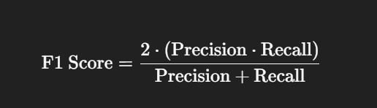
F1 score — the harmonic mean of precision and recall
- Why HARMONIC mean? use the harmonic mean when a SMALL value should pull the average down. If either precision or recall is tiny, F1 becomes tiny — arithmetic mean would hide the weakness (P=1.0, R=0.0 → arithmetic 0.5, harmonic 0).
- Macro-F1: the simple arithmetic average of all per-class F1 scores — treats every class equally, so it reflects performance across the whole dataset including small classes.

F-beta score
Generalizes F1 with a knob β: β = 1 → precision and recall matter equally (F1); β < 1 → precision matters more; β > 1 → recall matters more. Memory trick: P comes before R, so β < 1 = Precision priority, β > 1 = Recall priority.
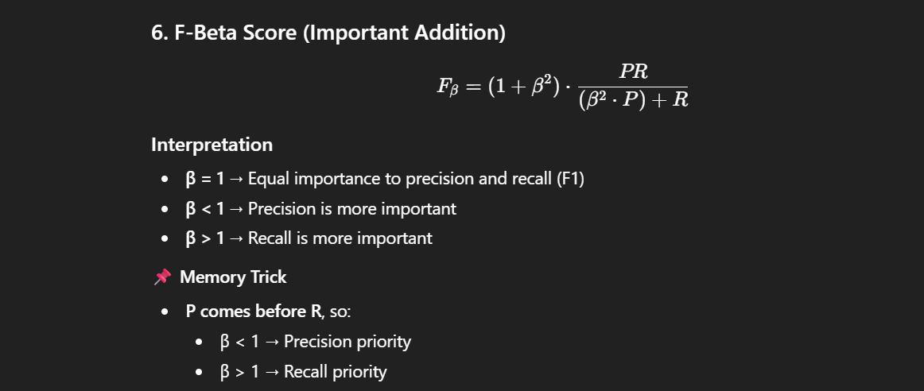
F-beta score formula and interpretation

8.3b Micro-F1 vs Macro-F1 vs Weighted-F1 vs Hamming Loss
These four summarise multi-class / multi-label performance in different ways. The difference is HOW they average across classes — which changes who "wins" when classes are imbalanced.
Setup for the examples: 3 classes with support (true counts) A = 90, B = 7, C = 3 (100 samples, imbalanced). Suppose per-class F1: A = 0.95, B = 0.60, C = 0.40.

Micro-F1
- How: pool ALL classes’ TP, FP, FN into one big count, then compute F1 once. Every SAMPLE (every decision) counts equally.
- Effect: dominated by the big class, because most decisions belong to it. Here micro-F1 ≈ 0.93 (close to class A). For single-label multi-class, micro-F1 = overall accuracy.
- Use when: you care about overall correctness across all predictions and are fine with big classes dominating.

Macro-F1
- How: compute F1 per class, then take a PLAIN average (every class weighted equally, regardless of size).
- Effect: small classes matter as much as big ones. Here macro-F1 = (0.95 + 0.60 + 0.40)/3 = 0.65 — much lower, because it exposes the weak rare classes.
- Use when: rare classes are important (fraud, disease) and you want to be penalized for ignoring them.

Weighted-F1
- How: average the per-class F1 but WEIGHT each by its support (class size).
- Effect: between micro and macro, but still tilts toward big classes. Here = (0.95×90 + 0.60×7 + 0.40×3)/100 = (85.5 + 4.2 + 1.2)/100 = 0.91.
- Use when: you want one overall number that respects class sizes but still accounts for each class’s F1.

Hamming Loss
- How: fraction of individual label-decisions that are WRONG (lower is better). Mostly used for MULTI-LABEL, where each sample has several yes/no labels.
- Effect: measures average per-label error, not per-sample. Getting 4 of 5 labels right on a row contributes 1 wrong out of 5.
- Use when: multi-label problems where you want overall label-level error rate.
Hamming example
Labels [Dog,Cat,Bird,Horse]; truth = [1,0,1,0], predicted = [1,1,0,0].
Wrong cells: Cat (0→1) and Bird (1→0) → 2 wrong out of 4 → Hamming loss = 0.5.
Metric | Averages over | Big class dominates? | Use when
Micro-F1 | all decisions pooled | Yes | overall correctness; = accuracy (single-label)
Macro-F1 | classes, equal weight | No | rare classes matter (fraud, disease)
Weighted-F1 | classes, by support | Somewhat | one number respecting class sizes
Hamming loss | label cells (lower better) | n/a | multi-label per-label error rate

＋ Added concept: Quick rule: imbalanced and you care about the rare class → Macro-F1. Want overall / accuracy-like → Micro-F1. Want a size-aware single score → Weighted-F1. Multi-label error rate → Hamming loss.
Q: On a 95%/5% imbalanced problem your micro-F1 is 0.94 but macro-F1 is 0.55 — what does that tell you?
The model is great on the majority class but poor on the minority one. Micro-F1 is high because most decisions are the easy majority; macro-F1 is low because it weighs the weak rare class equally. If the rare class is the point (fraud), trust macro-F1 and fix the minority performance.
Q: Why is micro-F1 equal to accuracy for single-label classification?
In single-label multi-class, every sample has exactly one prediction, so pooled TP across classes = number of correct predictions, and total pooled FP = FN = the misclassifications. Plugging those into F1 gives the same value as correct/total, which is accuracy.

8.4 ROC Curve and AUC
ROC = plot of True Positive Rate (y-axis) vs False Positive Rate (x-axis) across ALL possible classification thresholds. A good classifier has high TPR and low FPR.
- The diagonal (y = x) is a RANDOM classifier. A curve BELOW the diagonal is worse than random — it is actively predicting the wrong class (flipping its outputs would help!).
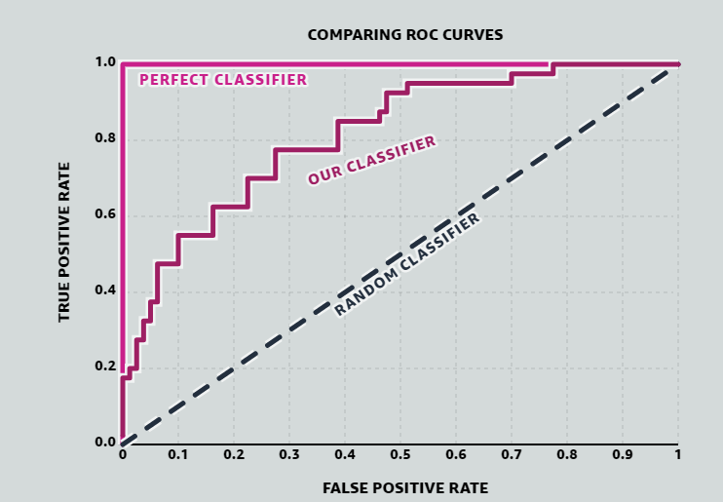
Comparing ROC curves: perfect vs our classifier vs random
- AUC: the area under the ROC curve. 0.5 = random guessing (no discriminative power); 1.0 = perfect separation. A higher AUC means the model is, on average, better at distinguishing positives from negatives — even if individual threshold points vary.
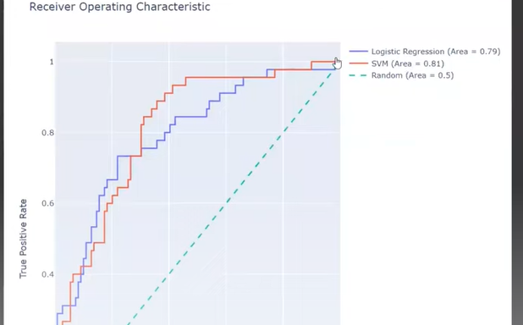
Two real models compared by AUC (Logistic Regression 0.79 vs SVM 0.81)
- Practical recipe: first choose the model with the highest AUC, THEN choose the threshold within that model to get the precision/recall balance your business needs.

Precision-Recall curve & PR-AUC (for imbalanced data)
The ROC curve can look overly OPTIMISTIC when the positive class is rare, because its x-axis (false-positive rate) has a huge negative denominator that hides a flood of false positives. The Precision-Recall curve fixes this by plotting PRECISION against RECALL across thresholds — and precision reacts directly to false positives.
- PR-AUC (a.k.a. average precision): the area under the PR curve. For rare-positive problems (fraud, disease, churn) it is a MORE informative summary than ROC-AUC.
- Baseline: a random classifier’s PR-AUC equals the positive PREVALENCE (e.g., 0.01 if 1% are positive), whereas ROC-AUC’s baseline is always 0.5 regardless of imbalance — which is exactly why ROC can mislead here.
- Rule of thumb: balanced classes or you care about both classes → ROC-AUC is fine. Rare positive class and you care mostly about catching it → prefer PR-AUC.

8.5 Multi-class Classification
Multi-class = y can take more than 2 values. Two strategy families:

1) Binary transformation
- OvR (One vs Rest): for n classes, build n models — A vs rest, B vs rest, C vs rest... Each outputs a probability; the class with the highest probability wins (ties broken randomly). With 10 classes → 10 models.
- OvO (One vs One): build one classifier for every PAIR of classes — n(n−1)/2 models. Prediction: every classifier votes; majority vote wins. With 10 classes → 45 models, so OvR is much faster in production.
OvO voting example (3 classes)
Classifier A-vs-B votes A; A-vs-C votes A; B-vs-C votes B → final prediction A (2 votes vs 1).

Why can OvR and OvO give different answers on the SAME data?
- Different decision boundaries: OvR learns each class against ALL others combined; OvO separates only two classes at a time.
- Different training data per classifier: each OvO model sees only two classes’ rows; each OvR model sees everything.
- Class imbalance effects: OvR suffers from built-in imbalance (1 class vs many); OvO pairs are usually balanced.

2) Native multi-class classifiers
SVMs, CART/decision trees, KNN, Naive Bayes and neural networks with multi-output layers can handle all classes SIMULTANEOUSLY — finding boundaries that separate each class from all others at once, rather than building separate models.

Multi-class confusion matrix and ROC
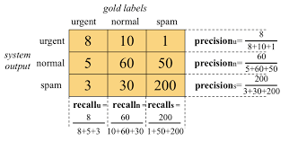
Multi-class confusion matrix with per-class precision and recall
The AUC-ROC curve is natively a BINARY tool; we extend it to multi-class using One-vs-Rest: with classes 0, 1, 2 we draw the ROC of "0 vs not-0", "1 vs not-1", "2 vs not-2" (OvO ROC pairs like 0-vs-1, 0-vs-2, 1-vs-2 are also possible).
Reading per-class AUC
AUC(class 0) = 0.90 → very good at detecting class 0; AUC(class 1) = 0.70 → moderate; AUC(class 2) = 0.55 → poor (barely better than random) — tells you exactly WHERE the model is weak.

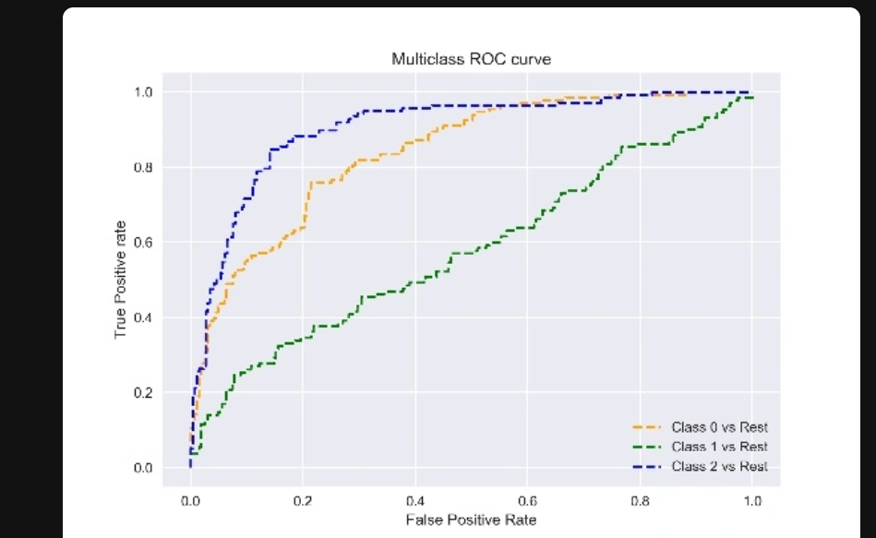
Multi-class ROC: one One-vs-Rest curve per class

8.6 Model Monitoring: Data & Concept Drift
A model that scored well at launch can silently rot in production as the world changes. Interviewers increasingly ask how you would DETECT and RESPOND to this.
- Data drift (covariate shift): the INPUT distribution changes — e.g., a new customer segment, a sensor recalibration. The relationship X→y may still hold, but the model now sees inputs unlike its training data.
- Concept drift: the RELATIONSHIP between inputs and target changes — e.g., spam tactics evolve, so the same email features now mean something different. The model becomes wrong even if the inputs look familiar.
- Drift can be: sudden (a shock), gradual (slow shift), or seasonal/recurring (holiday patterns).

How to detect it
- Monitor inputs: compare live feature distributions to training with statistics like the Population Stability Index (PSI) or a KS test — catches data drift before labels even arrive.
- Monitor performance: track accuracy / AUC / error over time once true labels come in — a falling metric signals concept drift.
- Drift detectors: online methods like ADWIN or DDM raise an alarm when the error rate shifts significantly.

How to respond
- Retrain: on recent data, on a schedule or triggered by an alert.
- Rolling window: keep training on the most recent period so the model tracks the current reality.
- Alert & roll back: page a human and revert to a known-good model if a fresh deploy degrades.
Example
A credit-fraud model’s precision drops from 0.92 to 0.70 over two months. Input monitoring shows transaction amounts have shifted upward (data drift from inflation) AND fraudsters adopted a new pattern (concept drift). Fix: retrain on the last 3 months with the new fraud examples, and add a rolling-window retrain job.

Tricky Interview Questions — Part 8
Q: 99.2% accuracy on fraud detection. Impressive?
Not necessarily. If only 0.8% of transactions are fraud, predicting "not fraud" for EVERYTHING also scores 99.2%. On imbalanced data always look at precision, recall, F1 and AUC — never accuracy alone.
Q: Cancer screening vs spam filtering — which metric do you prioritize?
Cancer screening: RECALL (a false negative is a missed cancer — catastrophic; false positives just trigger more tests). Spam filter: PRECISION (a false positive sends a real important email to spam — worse than letting one spam through). Matching the metric to the COST of each error type is the whole point of this question.
Q: What does AUC = 0.8 actually mean, in one sentence?
If you pick one random positive and one random negative example, there is an 80% chance the model assigns the positive a higher score. AUC is a RANKING measure — it is threshold-independent.
Q: My model’s ROC curve is BELOW the diagonal. Is it useless?
Ironically, no — it is consistently wrong, which is information. Inverting its predictions gives AUC = 1 − AUC_old, i.e., a better-than-random model. Usually it signals flipped labels or an inverted score somewhere in the pipeline.
Q: Why is F1 the harmonic mean instead of the arithmetic mean?
The harmonic mean collapses toward the SMALLER value. Precision 1.0 with recall 0.01 averages to 0.505 arithmetically (looks okay) but ≈ 0.02 harmonically (correctly terrible). F1 forces the model to be good at BOTH.
Q: High AUC but business results are bad. How?
AUC measures ranking across all thresholds, but production uses ONE threshold. The chosen cutoff may sit in a bad region (e.g., terrible precision at the recall you need), or the class distribution / costs in production differ from the test set. Always follow AUC selection with explicit threshold tuning on precision/recall.

Part 9 — Unsupervised Learning: Clustering
There is no single "best" clustering method — the choice depends on data distribution, density variation, cluster shape and whether you know the number of clusters in advance.

9.1 K-Means
- Partitions data into K clusters. Algorithm: (1) choose K; (2) randomly initialize K centroids; (3) assign each point to its nearest centroid; (4) update each centroid as the MEAN of its assigned points; (5) re-measure distances and re-assign; repeat until centroids stop changing.
- Limitations: must specify K; sensitive to outliers (the mean gets dragged); assumes spherical clusters; results vary between runs (random initialization).

K-Means++ (smart initialization)
- Identical algorithm — only the INITIALIZATION is smarter: pick the first centroid randomly; for every other point measure the distance to its nearest existing centroid; pick the next centroid from the data points with probability PROPORTIONAL TO THE SQUARED DISTANCE. Every following centroid (2nd...Kth) is chosen this way → initial centroids spread out, far fewer bad runs.

K-Medoids
- Medoid: an ACTUAL data point in the cluster whose total distance to all other points in the cluster is minimal (vs the centroid, which is an average and may not be a real point).
- Algorithm: choose K data points as initial medoids; assign non-medoid points to the nearest medoid; for each cluster compute the total distance cost and swap to whichever point gives the lowest cost as the new medoid; repeat until no change.
- Strength: robust to outliers and noise — extreme values cannot drag the cluster centre because the centre must be a real point. Weakness: computationally expensive.

Choosing K
＋ Added concept: Your notes flagged "must specify K" as a limitation but never said HOW to choose it — interviewers always follow up with this. Elbow method: plot inertia (within-cluster sum of squared distances) versus K; inertia always falls as K grows, but at the "elbow" the improvement suddenly flattens — pick that K. Silhouette score: for each point, compare its cohesion (distance to its own cluster) with its separation (distance to the nearest other cluster); score ranges −1 to +1; pick the K with the highest average silhouette. The elbow is quick and visual; silhouette is more rigorous.

9.2 DBSCAN
Density-Based Spatial Clustering of Applications with Noise — unsupervised, density-based. Assumes clusters are dense regions separated by low-density regions.
- Parameters: ε (epsilon) = neighbourhood radius; MinPts = minimum points to form a dense region.
- Point types: Core point — at least MinPts within ε. Border point — fewer than MinPts but within ε of a core point. Noise — not reachable from any core point (gets NO cluster, label −1).
- Process: pick an unvisited core point → start a cluster → add all density-reachable core points → add border points (border points do not expand the cluster further) → repeat for remaining points.
- Pros: arbitrary-shaped clusters; no need to specify the number of clusters; built-in outlier detection. Cons: sensitive to ε; struggles in high dimensions.

9.3 Mean-Shift Clustering
- Centroid-based; discovers the number of clusters automatically. Place a circular window (kernel) of radius r on a data point; compute the mean of the points inside; shift the window centre to that mean; repeat with multiple sliding windows until all points fall within stable windows. Overlapping windows: the one containing more points prevails.
- Pros: no K needed; handles arbitrary shapes. Cons: choosing window size r is hard; computationally expensive — O(n²).
Method | Need K? | Cluster shape | Handles outliers | Key weakness
K-Means | Yes | Spherical | Poorly (mean dragged) | Random init, outliers
K-Medoids | Yes | Spherical-ish | Well (real-point centre) | Expensive
DBSCAN | No | Arbitrary | Marks them as noise | Choosing ε, high-dim
Mean-Shift | No | Arbitrary | Reasonable | O(n²), choosing r

Tricky Interview Questions — Part 9
Q: K-Means gives different clusters every run. Bug?
No — random centroid initialization makes K-Means converge to different LOCAL optima. Fixes: K-Means++ initialization, run multiple times and keep the lowest-inertia result (n_init in sklearn), or fix the random seed for reproducibility.
Q: Why does K-Means fail on ring/moon-shaped data, and what works instead?
K-Means assigns by distance to a centroid, which implicitly carves space into convex, roughly spherical cells — a ring’s centroid sits in its empty middle. Density-based methods (DBSCAN) or spectral clustering follow the actual shape of dense regions and handle rings/moons.
Q: K-Means vs K-Medoids in one sentence each — when to prefer which?
K-Means: faster, uses the mean → preferred for large, clean datasets. K-Medoids: centre is a real data point and total distance (not squared) is minimized → preferred when outliers exist or when the "centre" must be an actual interpretable example.

Part 10 — Anomaly / Outlier Detection

10.1 Statistical Methods

Z-Score
- Measures how many standard deviations a point is from the mean. Assumes the data is normally distributed. Rule of thumb: |Z| > 3 → outlier.
- Limitation 1 — sensitive to the outliers themselves: a massive outlier pulls the MEAN toward itself and inflates the SD, which "masks" the outlier — it ends up looking normal.
- Limitation 2 — the threshold 3 is arbitrary: in very large datasets some extreme values are EXPECTED naturally.

Modified Z-Score
Replaces mean with the MEDIAN and SD with the MAD (median absolute deviation) — both are unaffected by extreme values. Rule: |modified Z| > 3.5 → outlier. Crucially, it does NOT assume normality, so it works for long-tailed, asymmetric and unknown distributions.
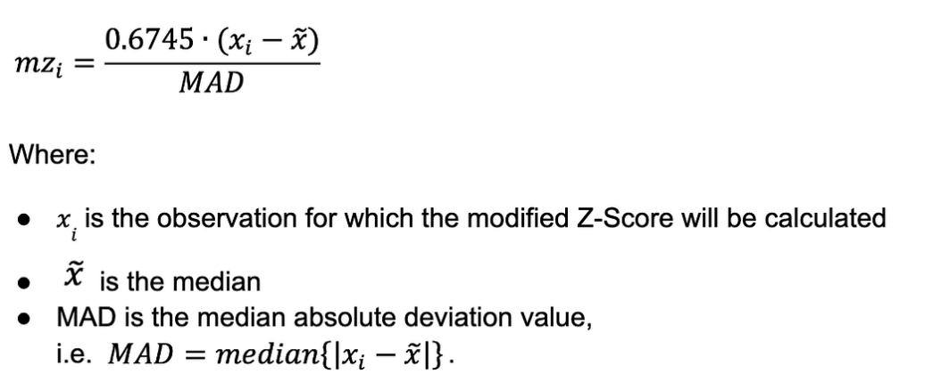
Modified Z-score: 0.6745 × (x − median) / MAD

IQR (Interquartile Range)
- Distribution-free. Q1 = 25th percentile, Q3 = 75th percentile, IQR = Q3 − Q1.
- Outlier bounds: below Q1 − 1.5×IQR or above Q3 + 1.5×IQR.
Example
Salaries: Q1 = 40k, Q3 = 80k → IQR = 40k. Bounds: 40k − 60k = −20k and 80k + 60k = 140k. A salary of 500k → outlier; 130k → not.

10.2 Density-Based: Local Outlier Factor (LOF)
- Compares the LOCAL density of a point with the density of its neighbours — an outlier is a point whose density is much lower than its neighbours’.
- k (neighbours): typical 10–30. Larger k → more global view; smaller k → more local sensitivity.
- LRD (Local Reachability Density): inverse of the average reachability distance to neighbours. Low LRD → point sits in a sparse region.
- LOF score = (average LRD of neighbours) / (LRD of the point). LOF ≈ 1 → normal; LOF > 1 → lower density than neighbours → potential outlier; higher = stronger anomaly.

10.3 Clustering-Based Approaches
- K-Means based: outliers = points far from their cluster centroid, or members of tiny/sparse clusters. Common recipe: apply Z-score or IQR to distances WITHIN each cluster. Limitations: must choose K, assumes spherical clusters.
- kNN distance: anomaly score = (average) distance to the k nearest neighbours. Normal points are close to neighbours; anomalies are isolated and far.
- DBSCAN: points labelled −1 (noise) are the outliers — anomaly detection comes built in. Bonus: no K needed, arbitrary shapes.

10.4 One-Class SVM (boundary-based)
- Trained on NORMAL data only — learns a boundary around normal observations (technically: a decision function separating normal data from the origin in feature space).
- New point inside the boundary → inlier; outside → outlier.
- Unsupervised/semi-supervised; kernel-based (RBF most common); SENSITIVE to feature scaling.

10.5 Isolation Forest
Builds many random trees; at each split it randomly selects a feature AND a random split value, then counts how many splits are needed to ISOLATE each point (path length).
- Key idea: fewer splits → easier to isolate → MORE anomalous. Points deep inside dense regions need many splits → normal.
- Contamination: a threshold selector — you tell the model what fraction of the data to flag, and it returns the most anomalous X% by score (you should verify by checking the anomaly score distribution).
✔ Correction: Wording fix: the flagged points are those with the HIGHEST anomaly scores / SHORTEST isolation paths (the original note said "bottom X%", which reads backwards — it is the top-X% most anomalous fraction).
Fraud-detection notes from practice (kept from your sheet)
Transaction amounts are heavily right-skewed → apply a log transform to transaction_amount.
Apply RobustScaler to all columns (median/IQR-based → outlier-resistant).
No labels (unsupervised) → validate by inspecting the anomaly-score distribution and by BACKTESTING on confirmed historical fraud cases.
Business rules can be layered on top, e.g., force all transactions above a high amount threshold (top 10%) to appear in the anomaly output.

Tricky Interview Questions — Part 10
Q: Why can the plain Z-score MISS a huge outlier?
Masking: the outlier itself inflates the mean and the standard deviation used to compute Z. With the statistics distorted toward it, its own Z-value shrinks below 3 and it looks normal. Median/MAD (modified Z) or IQR are immune because medians ignore extremes.
Q: A point is globally normal but locally strange — which detector catches it?
LOF. A point with moderate values sitting just outside a very tight cluster has a far lower density than its neighbours → LOF ≫ 1, while global methods (Z-score, IQR) see nothing unusual. That local-vs-global contrast is LOF’s entire purpose.
Q: Why is Isolation Forest fast compared to distance-based detectors?
It never computes pairwise distances. Random splits isolate anomalies in O(n log n)-ish time, and trees are independent (parallelizable). kNN/LOF need neighbour searches, which get expensive as n and dimensionality grow.
Q: You set contamination = 0.05. What exactly happens?
The model does NOT "find" 5% anomalies — it RANKS all points by anomaly score and labels the top 5% as anomalous, period. If the real anomaly rate is 1%, you generate false alarms; if it is 10%, you miss half. Contamination is your assumption, not the model’s discovery — sanity-check it against the score distribution.

Part 11 — Saving Models & Special Topics

11.1 Saving a Model: Pickle vs Joblib
Once a model is trained you must SAVE it to disk so you can reload and use it later without re-training. The two standard Python ways are pickle and joblib. Both do "serialization" — turning a Python object into a byte stream on disk — and both save the WHOLE fitted model (its learned parameters + settings).

Pickle
- What: Python’s built-in serializer. Works for almost any Python object, not just ML models.
- Good for: small models, custom Python objects, dictionaries, pipelines — anything.
Pickle
import pickle
# save
with open("model.pkl", "wb") as f:
pickle.dump(model, f)
# load
with open("model.pkl", "rb") as f:
model = pickle.load(f)

Joblib
- What: a library optimized for objects that contain large NumPy arrays (which most scikit-learn models do).
- Good for: scikit-learn models, Random Forests, big arrays — it stores arrays more efficiently, so it is usually FASTER and produces smaller files for these.
Joblib
import joblib
# save
joblib.dump(model, "model.joblib")
# load
model = joblib.load("model.joblib")

Which to use?
Aspect | Pickle | Joblib
Best for | any Python object, small models | scikit-learn / large NumPy-array models
Speed & size (big arrays) | slower, larger file | faster, smaller file
Part of standard library | yes (built-in) | no (pip install joblib)
Typical ML use | fine for small/simple objects | the usual choice for sklearn models

＋ Added concept: Rule of thumb: for scikit-learn models (Random Forest, XGBoost wrappers, pipelines with big arrays) use JOBLIB — it is faster and smaller. For small custom objects or when you want zero extra dependencies, pickle is fine. Both save the full trained model; the difference is efficiency, not capability.
✔ Correction: Security & versioning: NEVER load a pickle/joblib file from an untrusted source — it can execute arbitrary code on load. Also, a saved model is tied to library versions; reloading with a very different scikit-learn/NumPy version can break or silently misbehave, so record the versions (e.g., in requirements.txt) alongside the file. For deep-learning models use the framework’s own format instead (PyTorch state_dict / torch.save, Keras model.save).

11.2 Which models can keep learning on new data (and which forget)
A very common interview question: if new data arrives, can you keep training the SAME model on just the new data without losing what it already learned? The answer depends on whether the model supports INCREMENTAL (online) learning.

Models that FORGET if you re-train on only new data
Most classic models have NO memory of past data. Calling fit() again starts from scratch and throws away everything learned before — they are trained in one shot (batch learning).
- Examples: Decision Tree, Random Forest, standard SVM, K-Nearest Neighbours stores all data so "adding" means keeping ALL old points (not true incremental), plain Linear/Logistic Regression via the normal equation, K-Means (standard).
- Why: fit() re-initializes the model and optimizes only on the data you pass now. There is no mechanism to merge old knowledge with new.
✔ Correction: "Re-training on only the new data" with these models causes catastrophic forgetting — the model keeps only the new patterns. To update them correctly you must RE-TRAIN on OLD + NEW data combined. A Random Forest cannot be meaningfully extended with just new rows; you rebuild it (or grow a fresh forest) on the full dataset.

Models that CAN keep learning incrementally (online learning)
Some models expose a partial_fit() method (in scikit-learn) that UPDATES the existing model using only the new batch, keeping prior learning. This is "online" or "incremental" learning — ideal for streaming data or data too big for memory.
- scikit-learn with partial_fit(): SGDClassifier / SGDRegressor (logistic & linear via gradient descent), MultinomialNB / BernoulliNB (Naive Bayes), PassiveAggressiveClassifier, MiniBatchKMeans, Perceptron.
- Gradient-descent / neural networks: naturally update step-by-step, so they can continue training on new batches (though they too can forget old patterns if you ONLY show new data — see below).
- Some boosting libraries: XGBoost / LightGBM can continue training by adding more trees (warm start / xgb_model=...), effectively learning from new data on top of the old model.
Incremental learning with partial_fit
from sklearn.linear_model import SGDClassifier
import numpy as np

clf = SGDClassifier(loss="log_loss")
classes = np.array([0, 1]) # must declare all classes up front

clf.partial_fit(X_batch1, y_batch1, classes=classes) # learn batch 1
clf.partial_fit(X_batch2, y_batch2) # UPDATE with batch 2
# old knowledge is kept and refined, not thrown away
Can it learn incrementally? | Models
YES (partial_fit / warm start) | SGDClassifier/Regressor, Naive Bayes, PassiveAggressive, Perceptron, MiniBatchKMeans, neural nets, XGBoost/LightGBM (add trees)
NO (re-train on old+new) | Decision Tree, Random Forest, standard SVM, KNN (keeps all data), normal-equation Linear Regression, standard K-Means

＋ Added concept: Even for models that CAN continue (neural nets), training ONLY on new data can still cause catastrophic forgetting of old patterns. Safe fixes: mix some old data with the new (rehearsal), keep a small memory buffer, or periodically re-train on the full dataset. True "learn new without forgetting old" is the field of continual / lifelong learning.
Q: New data arrives weekly. Your model is a Random Forest — can you just fit() on the new week’s rows?
No. Random Forest has no memory; fit() rebuilds it from scratch on only the new rows and forgets everything prior. You must re-train on OLD + NEW combined, or switch to an incremental model (e.g., SGDClassifier with partial_fit) if you need true online updates.
Q: Which scikit-learn method enables online learning, and what is the catch?
partial_fit(). It updates the existing model with a new batch instead of restarting. Catch: for classification you must pass the full list of classes on the first call, and not every estimator supports it (mainly SGD-based models, Naive Bayes, MiniBatchKMeans).

11.3 Autoencoders
An autoencoder is a neural network that learns to COPY its input to its output — but through a narrow middle layer that forces it to compress the data first and then rebuild it. By learning to reconstruct the input, it discovers the most important underlying patterns (a compact representation), with NO labels needed (it is unsupervised / self-supervised).

The logic / architecture
- Encoder: squeezes the input (many features) down into a small set of numbers called the LATENT representation or "bottleneck" (the code).
- Bottleneck (latent space): the compressed summary — much smaller than the input. This forces the network to keep only what matters and drop noise.
- Decoder: takes the small code and tries to REBUILD the original input from it.
- Training: minimize RECONSTRUCTION ERROR — the difference between the input and the rebuilt output (e.g., MSE). The target IS the input itself, so no labels are required.
Autoencoder structure
Input (e.g., 784 numbers)
| Encoder (compress)
v
Bottleneck / latent code (e.g., 32 numbers) <-- the learned summary
| Decoder (rebuild)
v
Output (784 numbers, ~ same as input)

Loss = difference(Input, Output) # reconstruction error (MSE)
Intuition: it is like learning to write a very short summary of a document and then reconstruct the document from the summary. If the rebuild is good, the summary captured the essence.
Simple example — image compression
Feed a 28×28 = 784-pixel digit image into an autoencoder with a 32-number bottleneck.
The encoder compresses 784 → 32; the decoder rebuilds 784 from those 32.
After training, those 32 numbers capture "what the digit looks like" — a 24× smaller representation that still rebuilds the image closely.

Why it is useful & where it is used
- Anomaly / fraud detection: train ONLY on normal data so the autoencoder reconstructs normal points well. A fraud/anomaly is unlike anything it saw, so it rebuilds BADLY → high reconstruction error flags it. (Very relevant to mule/fraud detection.)
- Dimensionality reduction: the bottleneck is a compressed feature set — like a non-linear PCA. Useful to shrink features before another model.
- Denoising: a "denoising autoencoder" is fed a noisy input and trained to output the clean version — used to clean images, audio, or signals.
- Image / data compression: store the small code instead of the full input.
- Feature learning / pre-training: learn useful representations from unlabeled data, then reuse them for a downstream task.
- Recommendation & missing-value imputation: reconstruct missing entries from the learned patterns.
＋ Added concept: Autoencoder vs PCA: PCA finds only LINEAR compression; an autoencoder (with non-linear activations) can capture CURVED, complex structure, so it often compresses better — at the cost of needing more data and training. A single-layer linear autoencoder is essentially PCA.
Q: How does an autoencoder detect fraud/anomalies without labels?
Train it only on NORMAL transactions so it becomes good at reconstructing them. At scoring time, a fraudulent/anomalous record does not match the learned normal patterns, so its reconstruction error is high. Flag anything above an error threshold as anomalous.
Q: Why put a narrow bottleneck in the middle?
The bottleneck forces compression. If the middle layer were as wide as the input, the network could just copy the input through (learn the identity) and learn nothing useful. Squeezing it makes the network keep only the essential structure and discard noise.
Q: Autoencoder vs PCA — when prefer the autoencoder?
When the data has non-linear structure. PCA is limited to linear directions; an autoencoder with non-linear layers can model curved manifolds and often reconstructs better. Prefer PCA when data is roughly linear, small, or you need speed and interpretability.

Part 12 — Project Case Study 1: Multi-Label Classification Model
One-line summary (say this first in an interview): I built a multi-label model that tags each customer support ticket with ALL the categories it belongs to (a ticket can be Billing AND Fraud at once). I had 10 candidate features, used feature selection to keep the strongest, tried several ensemble methods, and picked the one that gave the best micro-F1 while handling rare labels.

1. Problem & why it is multi-label
Each ticket can carry MORE THAN ONE label at the same time — e.g., a message may be both "Billing" and "Fraud". That is multi-LABEL (many labels per row), which is different from multi-CLASS (exactly one class per row). So ordinary accuracy and softmax do not apply directly.
- Labels (5): Billing, Technical, Account, Fraud, Feedback — any combination can be true.
- Why it matters: correct multi-tagging routes a ticket to all the right teams at once, cutting hand-offs and response time.

2. Data & the 10 candidate features
~120,000 tickets. The 10 features I started with:
- Metadata: channel, customer tenure, product type, prior ticket count, time-of-day.
- Text-derived: ticket length, # of money-related keywords, sentiment score, # of error-code mentions, urgency words count.

3. Feature selection — 10 → the important ones
I did not keep all 10 blindly. My steps:
- Variance + correlation filter: dropped one of each highly-correlated pair (ticket length and # keywords were correlated → kept keywords).
- Mutual Information per label: MI is multi-label friendly — a feature can matter for ONE label only (money-keywords mattered hugely for Fraud/Billing, barely for Technical).
- Model-based importance (Random Forest) + SHAP: confirmed the top drivers and gave per-label direction.
- Result: kept 6 features — money-keywords, error-code mentions, sentiment, product type, channel, urgency words. Dropped tenure, prior-count, time-of-day, ticket length (low signal or redundant).
＋ Added concept: Key point I make in interviews: in multi-label, "importance" is PER LABEL. A feature useless overall can be the top feature for one rare label — so I scored features per label, not just globally.

4. Handling the multi-label structure
I compared the three standard ways to turn multi-label into something models can learn:
Approach | Idea | Pro / Con
Binary Relevance | one separate classifier per label | simple, parallel / IGNORES label correlation
Classifier Chains | each classifier also sees earlier labels’ predictions | captures correlation (Fraud↔Billing) / order matters, slower
Label Powerset | treat each label-combination as one class | captures correlation / explodes with many labels, rare combos

I used Classifier Chains because Fraud and Billing clearly co-occur, and Binary Relevance was missing those joint cases.

5. Ensemble methods I tried & the final choice
I wrapped each approach around ensemble base learners and compared:
Model (base learner) | Micro-F1 | Macro-F1 | Hamming loss | Note
Random Forest (Binary Relevance) | 0.81 | 0.68 | 0.090 | native multi-label, strong baseline
XGBoost (Binary Relevance) | 0.84 | 0.71 | 0.078 | better on frequent labels
XGBoost (Classifier Chains) | 0.86 | 0.76 | 0.071 | best — captures label correlation
Stacking (RF+XGB → LogReg meta) | 0.86 | 0.77 | 0.070 | marginal gain, more complex

Chosen model: XGBoost in a Classifier-Chain setup. It gave almost the same score as stacking but was far simpler to deploy and explain — in production, a small, maintainable model beats a slightly-better but fragile one.

6. Metrics — why NOT accuracy
- Subset (exact-match) accuracy is too harsh — getting 4 of 5 labels right still scores 0. I reported it but did not optimize it.
- Micro-F1 was my main metric — it weighs every label-decision equally and handles imbalance across labels.
- Macro-F1 watched the RARE labels (it averages labels equally, so a weak rare label shows up).
- Hamming loss tracked the overall fraction of wrong label cells (lower is better).

7. Difficulties faced & how I overcame them
- Label imbalance (Feedback was rare): macro-F1 exposed it; I used per-label class weights and tuned a SEPARATE probability threshold per label instead of a flat 0.5.
- Label correlation ignored at first: Binary Relevance missed Fraud+Billing combos → switched to Classifier Chains, which feeds earlier labels into later ones.
- Threshold tuning: a single 0.5 cutoff hurt rare labels → I picked each label’s threshold by maximizing its F1 on validation.
- Choosing the metric: stakeholders first asked for "accuracy"; I showed why exact-match accuracy is misleading here and aligned everyone on micro/macro-F1.

8. Result & impact
Micro-F1 rose from 0.81 (baseline) to 0.86, and the rare "Feedback" label’s recall roughly doubled after per-label thresholds. Auto-tagging cut manual re-routing noticeably and sped up first response.
Q: Why not just use multi-class / softmax?
Softmax forces the probabilities to sum to 1 — it assumes exactly ONE class. Here a ticket can have several labels at once, so I need independent per-label probabilities (sigmoid per label), not a single softmax.
Q: How is Classifier Chains different from Binary Relevance?
Binary Relevance trains one independent classifier per label and ignores how labels relate. Classifier Chains passes each predicted label as an extra feature into the next classifier, so it can learn that Fraud and Billing tend to occur together.
Q: Why report both micro and macro F1?
Micro-F1 is dominated by frequent labels and reflects overall decision quality; macro-F1 averages labels equally, so it reveals whether rare labels are being handled — together they stop a model that "looks good" by ignoring rare labels.

Part 13 — Project Case Study 2: Mule Account Detection (Imbalanced Fraud)
One-line summary: I built a model to flag MULE accounts from transaction data. Only 9% of accounts were mules (imbalanced), so accuracy was useless; I did feature selection on 10 features, handled the imbalance carefully, compared ensemble methods, and chose the one that caught the most mules at an acceptable false-alarm rate — with SHAP for audit.

1. Problem & the imbalance challenge
A mule account receives illicit money and passes it on. In my data only 9% of accounts were mules and 91% genuine. The trap: a model that predicts "genuine" for everyone is 91% accurate yet catches ZERO mules — so accuracy is the wrong goal. The real goal is high RECALL on mules without drowning investigators in false alarms.

2. Data & the 10 candidate features
Account-level features engineered from raw transactions:
- Flow: in/out amount ratio, average transaction amount, total monthly volume.
- Behaviour: transaction velocity (txns/day), # unique counterparties, night-time transaction %, round-amount transaction %.
- Pattern: dormant-then-sudden-burst flag, cash-in/cash-out ratio, account age.

3. Feature selection — 10 → important ones
- Correlation + VIF: monthly volume and average amount were correlated → kept one to avoid multicollinearity.
- Model-based importance (XGBoost) + SHAP: ranked drivers; in AML, SHAP is essential because investigators and regulators must know WHY an account was flagged.
- Kept 6 features: in/out ratio, velocity, # counterparties, night-time %, dormant-then-burst flag, cash-out ratio. These matched known mule behaviour (fast pass-through, many counterparties, odd hours).
- Dropped: account age, round-amount %, monthly volume (redundant or weak).

4. Handling the 9% imbalance (the heart of the project)
- Right metric first: I optimized PR-AUC and recall-at-fixed-precision, NOT accuracy or plain ROC-AUC (ROC looks optimistic on rare positives).
- Class weights / scale_pos_weight: told the model a missed mule costs far more than a false alarm.
- SMOTE on the TRAINING fold only: to enrich the minority — applied inside the CV pipeline, AFTER the split, never before (that would leak).
- Threshold tuning: moved the decision threshold off 0.5 to hit the recall the fraud team needed at a workable alert volume.
✔ Correction: The biggest mistake to avoid here is applying SMOTE before the train/test split — synthetic points built from test rows leak into training and give a falsely high score. I always resample inside the pipeline on the training fold only.

5. Ensemble methods I tried & the final choice
I compared bagging and boosting families, tuned for recall at precision ≥ 0.80:
Model | Recall (mules) | Precision | PR-AUC | Note
Logistic Regression (baseline) | 0.61 | 0.70 | 0.66 | linear, misses non-linear patterns
Random Forest (bagging) | 0.74 | 0.80 | 0.79 | strong, reduces variance
XGBoost (boosting) | 0.82 | 0.81 | 0.85 | best recall, handles imbalance well
LightGBM (boosting) | 0.81 | 0.82 | 0.85 | similar to XGB, faster to train
Stacking (RF+XGB+LGBM) | 0.83 | 0.81 | 0.86 | tiny gain, harder to explain

Chosen model: XGBoost with scale_pos_weight and a tuned threshold. It gave the best recall at the required precision, trained fast, and — crucially for AML — pairs cleanly with SHAP so every alert comes with its reasons. I did not pick stacking: the 1-point gain was not worth the loss of explainability and the extra maintenance.

6. Evaluation
- Validation: stratified K-fold (keeps the 9% ratio in each fold); for the final test I used a later TIME period to mimic real deployment and catch drift.
- Metrics reported: confusion matrix, precision, recall, F1, PR-AUC — and cost (missed mule vs false alarm), which is what the business actually cares about.

7. Difficulties faced & how I overcame them
- Severe imbalance (9%): accuracy was meaningless → switched to PR-AUC/recall, used class weights + SMOTE-on-train + threshold tuning.
- Data leakage risk: early on, scaling and SMOTE were done before the split and scores looked too good → moved ALL preprocessing inside a pipeline fit on the training fold only.
- Explainability for regulators: a black-box flag is not acceptable in AML → added SHAP so each alert lists the top reasons (e.g., high velocity + many counterparties + night activity).
- Label noise & delay: confirmed-mule labels arrive late and some are uncertain → I trained on confirmed cases, treated unconfirmed as a separate review bucket, and planned periodic re-labelling.
- Concept drift: mule tactics change → I set up monitoring (PR-AUC and feature-distribution checks over time) and scheduled retraining on a rolling window.
- Alert volume vs capacity: too many alerts overwhelm investigators → I tuned the threshold with the team to match their daily review capacity, trading a little recall for a workable queue.

8. Result & impact
Recall on mules went from 0.61 (logistic baseline) to 0.82 with XGBoost at precision ~0.81, and PR-AUC from 0.66 to 0.85. Investigators got a ranked, SHAP-explained alert list, so they reviewed the riskiest accounts first.
Q: Why is accuracy the wrong metric here, and what did you use instead?
With 9% mules, always predicting "genuine" scores 91% accuracy while catching zero mules. I used PR-AUC and recall-at-fixed-precision, which focus on how well the rare positive class is caught.
Q: ROC-AUC vs PR-AUC for this problem?
ROC-AUC can look optimistic on rare positives because its false-positive-rate denominator is dominated by the huge genuine class. PR-AUC uses precision, which reacts directly to false positives, so it is more honest for rare-fraud detection.
Q: How did you prevent data leakage with SMOTE and scaling?
I put every preprocessing step (scaling, imputation, SMOTE) inside a pipeline and fit it only on the training fold of each CV split, then applied it to the validation fold. SMOTE never sees test rows, so nothing leaks.
Q: Why XGBoost over the stacking ensemble that scored slightly higher?
The stacking model gained about 1 point of PR-AUC but was harder to explain and maintain. In AML, explainability (SHAP) and stability matter more than a marginal metric gain, so the simpler XGBoost was the right production choice.
Q: How would you keep the model healthy after deployment?
Monitor PR-AUC and feature distributions over time to catch concept/data drift, retrain on a rolling recent window, and keep a feedback loop with investigators so newly confirmed mules refresh the labels.

